Timeless Innovation.
BRACE Collection, design Takeda Katsuya in collaboration with Japanese company Tatehiko.

A collaboration born from the fortunate encounter between Takeda Katsuya Design studio, based in Milan, and the company Tatehiko based in the Japanese regional city of Ashikaga. The result is the BRACE collection, a new line of easy-to assemble pieces of furniture of the finest quality composed of side tables, coffee tables and shelves that were officially presented in preview during Milan Design Week 2023, in the 5 VIE Art + Design district, via del Torchio 5/7 at Takeda Katsuya Design studio-showroom.

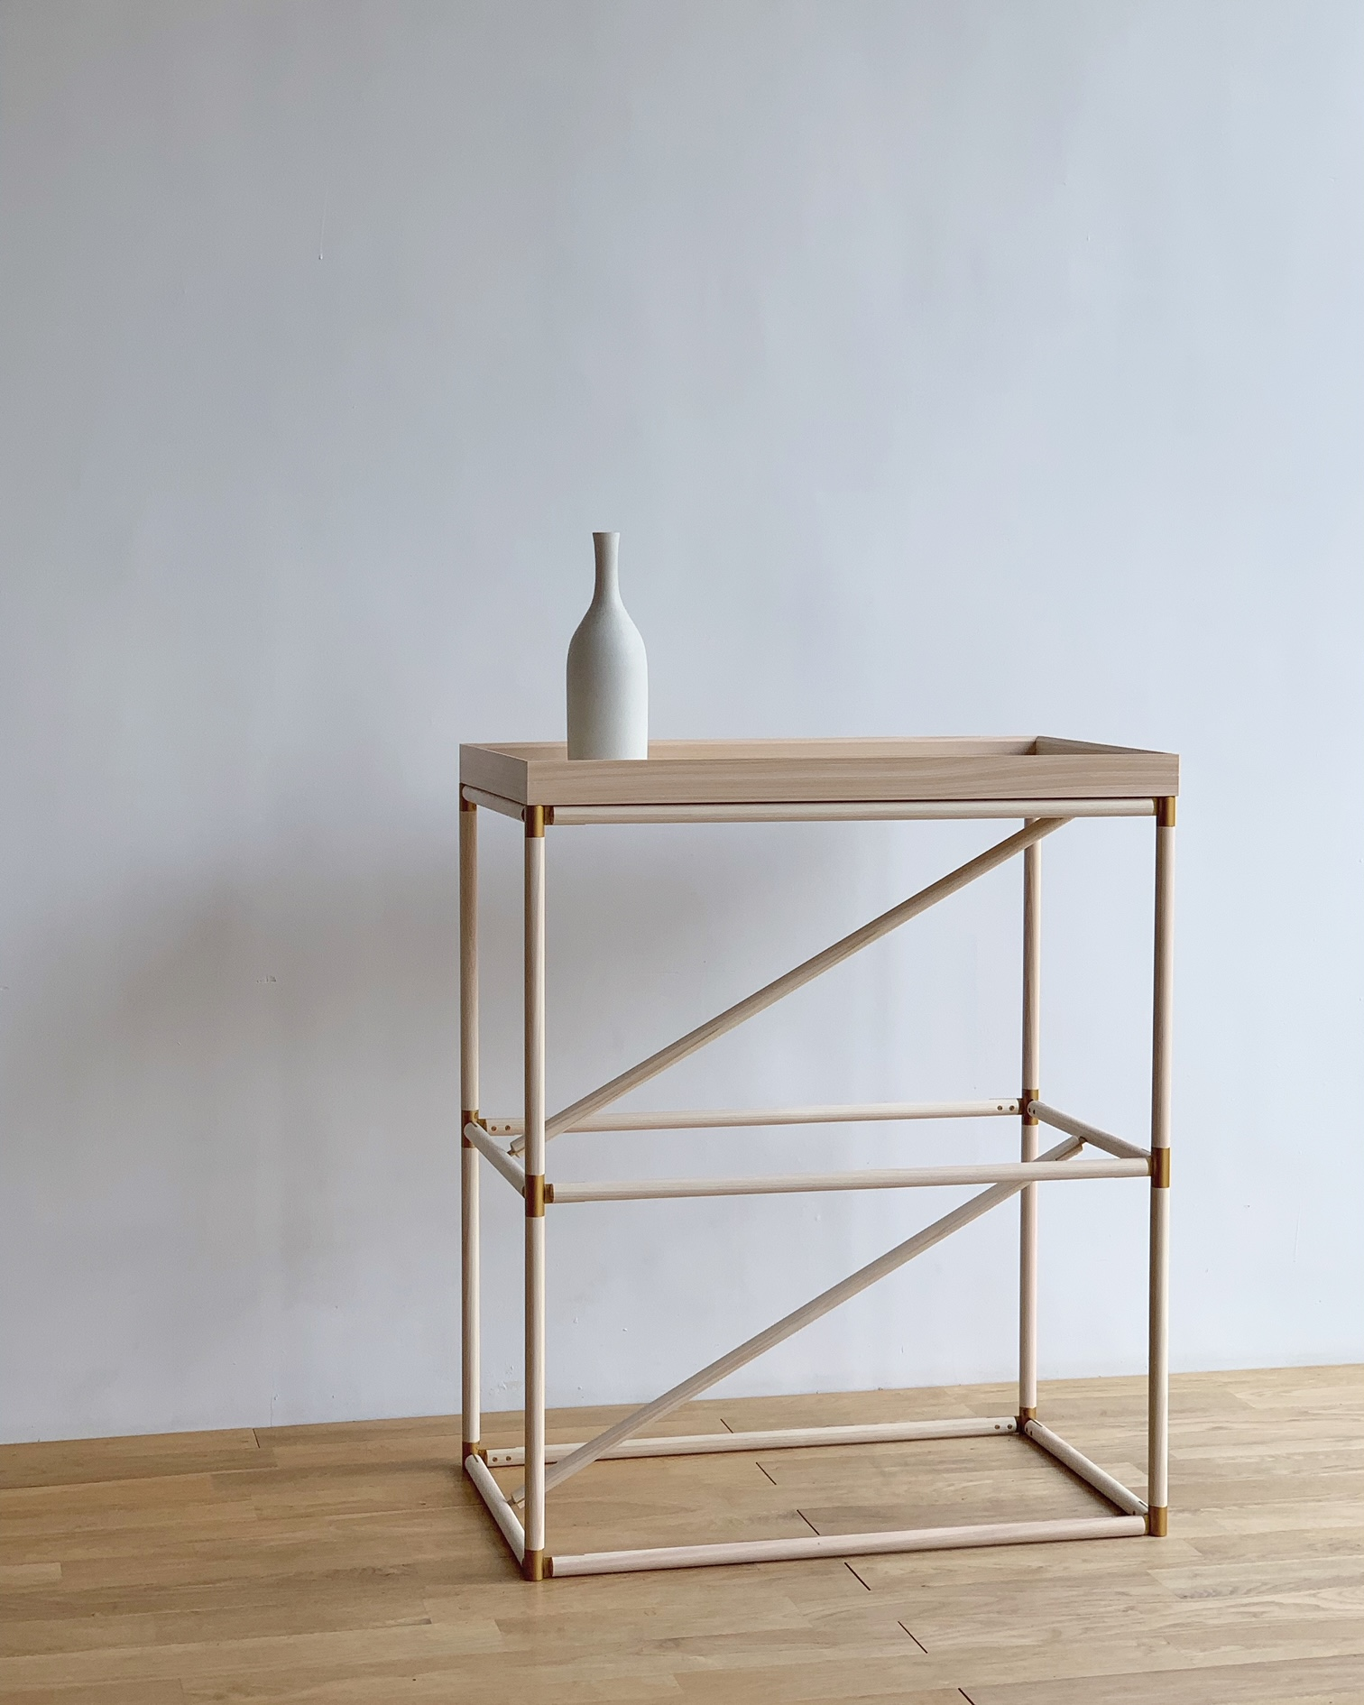
"BRACE" is a new design concept that features a structure with very light, elegant, and functional supports, characterised by diagonal lines that allow for different configurations, sizes, and applications, making it an extremely versatile and portable piece of furniture suitable for any environment and atmosphere. The BRACE collection is the result of the established local expertise of Tatehiko, passed down through three generations, in which their production process is based on the philosophy of valuing and sustainably using local resources. BRACE is a collection with strong aesthetic appeal, with a structure made from high quality Hinoki cypress wood, typical material used in the construction and furniture industry in Japan since ancient times. The joints are made from a traditional Japanese architectural technique called Shiguchi that uses steel to provide strength despite the slim structures. It is developed with light-toned supports, in delicate white colours with brass joints, inspired by the shoots that grow in the forests of Tochigi, where the company Tatehiko is located.

Hinoki wood is a quality material from a technical point of view, due to its resistance, flexibility, and wear resistance. Its neutral white tone perfectly matches any environment, whether it is oriental or western, and the intrinsic divinity of the material gives the furniture a high level of sophistication.

BRACE is a collection that guarantees infinite creative and application possibilities. Thanks to its simple design, the BRACE parts can be easily replaced, allowing it to last through time. BRACE is a refined piece of furniture that blends perfectly into the comfort of any living space.

Dimension side table: W400mm X D300 mm X H550 mm, coffee table W650 mm X D650 mm X H380 mm, shelf W650 mm X D300 mm X H793 mm.

The removable top tray is light and can easily be carried around.

About Takeda Katsuya Design

The Takeda Katsuya Design architecture studio was founded in 2014 by the Japanese designer Takeda Katsuya along with his wife – the artist and painter Iida Takako. The studio recently inaugurated its workspace and exhibition showroom in the heart of Milan: a 150 m² space exposed to the historical Via del Torchio through large windows. The TKD studio, which today consists of a team of six architects and designers, deals mainly with interior design, product design, concept design, retail planning and turnkey project management. Its consolidated experience lies mainly in the fields of high-end fashion retail, catering, luxury residences and accommodation, with projects all over Italy and Japan.

About Tatehiko

Tatehiko is a woodworking products brand of Sei Furniture Studio Co., Ltd. In 1892, we started out as a woodwork manufacturer under the name of "Tatehiko" in Ashikaga City, Tochigi Prefecture, a town of history and culture. We make furniture and interior goods by making use of traditional techniques that have been passed down for more than 100 years since our founding.
It is characterized by making things that are delicately handmade by Japanese people while taking high-precision machining. Our most important task is to sincerely face the precious wood received from the forest, breathe new life as daily life tools, and bridge it to the people who use it. We will continue to make daily life tools that will become beautiful as we use it for a long time.

Takeda Katsuya Design
Via del Torchio 5/7, 20123 Milano
+39 02 8450 1328
info@takedakatsuyadesign.com

Per richieste stampa e interviste personalizzate:

OGS PR and Communication

Via Koristka 3, Milano
+39 02 3450610
info@ogscommunication.com
www.ogscommunication.com
press.ogscommunication.com

