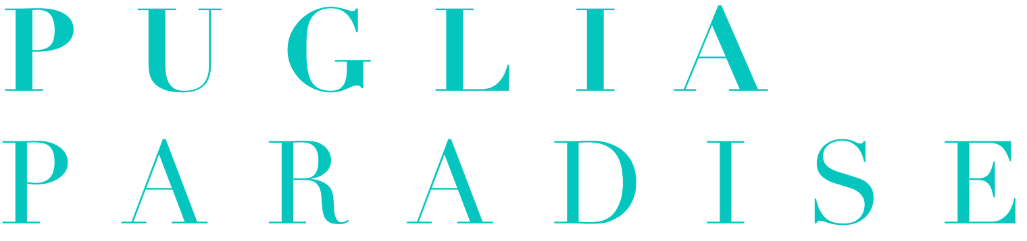

The role of the Guest Angel. Puglia Paradise

The hospitality and tourism industry is constantly evolving to provide guests and travelers with personalized stays based on specific requests that must be managed by competent, professional, proactive, responsive, and available staff.

The Guest Angel is born, a key figure introduced by Puglia Paradise, a professional management company of trulli and holiday villas with private pool and premium services of qualitative excellence in the most prestigious and fascinating locations of Puglia.

The Guest Angel is the tailor of hospitality, the personal concierge of the Guest, promptly and professionally responding to every request and discreetly ensuring that the stay is going in the best possible way.

“Quando si arriva in un luogo non conosciuto, avere un punto di riferimento è importante e fa sicuramente la differenza rispetto ad ogni altra struttura o circuito turistico.”
“Any request, no matter how big or small, was met with calm, professional and friendly ease. He really made our stay! ”
“Professionnalisme, écoute, réactivité et disponibilité.”

These are some of the reviews on Guest Angels from the guests of Puglia Paradise's properties: an impeccable point of reference for travelers, a welcoming and assisting figure before, during and after the stay, with the mission of ensuring guests an unforgettable and completely relaxing vacation.

The Guest Angel plays the role of a personal concierge, a key figure for the premium services offered by Puglia Paradise.

The Guest Angel's work begins immediately after the guest's reservation with the first contact via text message followed by a call. In this initial phase, the Guest Angel sends the location of the villa or meeting point, collects all the necessary information for check-in, and answers guests' questions and curiosities. In case of specific needs, the Guest Angel also books extra services and experiences as requested.

On the day of arrival, the Guest Angel verifies that the online check-in has been completed correctly and welcomes the Guest, illustrating the villa and explaining all the technical information to make the most of all the services it offers, describing the area where it is located and illustrating everything that may be useful to enjoy a pleasant and unforgettable holiday.

During the stay, the Guest Angel continues to be present when requested, always leaving the privacy of the Guests first, but remaining available for any needs or requests for extra services. At the time of check-out, he collects feedback from travelers.

The work of the Guest Angel is not limited to responding to the guest's requests or solving any problems. The real strength of this figure that sets it apart from other professional figures in the hospitality industry is the empathic relationship that is created with the Guest, which can arise even before arrival at the villa. In this way, the Guest Angel becomes a true Travel Agent who personalizes the stay based on the needs, finding the best way to relate to all Guests, surprising them with small original and personalized gifts to pamper and make the stay unique.

Friendly but professional, kind but never intrusive: the Guest Angel is a unique professional figure in the non-hotel industry sector, which fully integrates into the vision of Puglia Paradise, guaranteeing high standards and premium services typical of a luxury facility capable of satisfying the most demanding guests.

PUGLIA PARADISE
Foro Buonaparte 59, 20121, Milano, Italy
info@pugliaparadise.com
www.pugliaparadise.com

For press inquiries and personalized interviews
OGS PR and Communication
Via Koristka 3, Milano 20154
info@ogscommunication.com
www.ogscommunication.com
press.ogscommunication.com

