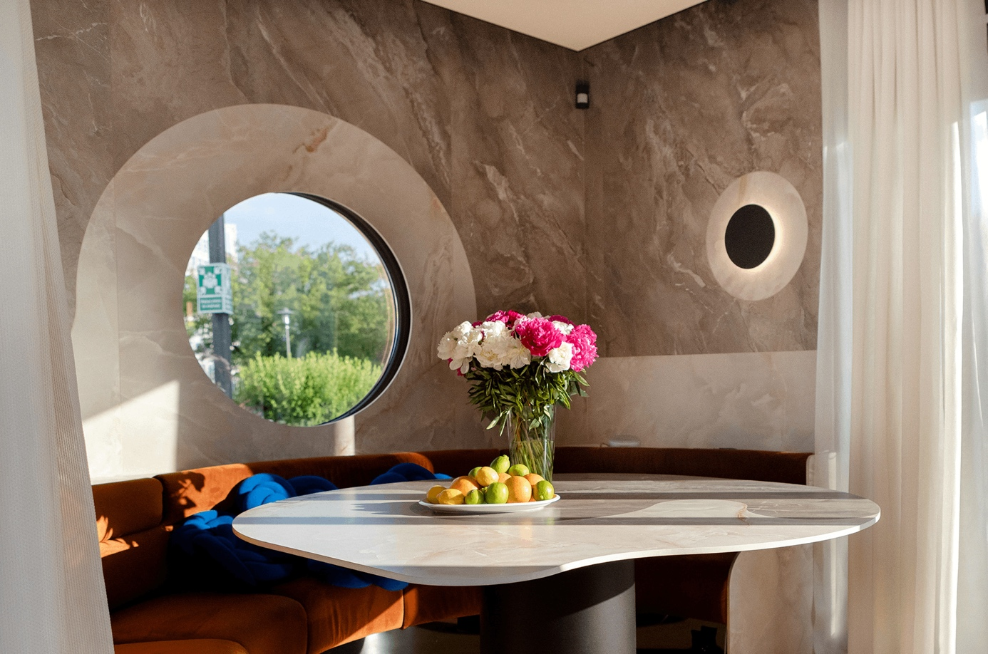
Mobile showroom Paradyż Home
Ceramika Paradyż invites you to a place of inspiring conversations, creative meetings and the latest trends in design. Paradyż Home is more than a mobile showroom. It is a meeting place for all enthusiasts of beautiful interiors, a space conducive to discussing design trends.
In the brand’s mobile showroom, visitors can take a closer look at the brand’s groundbreaking new product – the market-unique TRI-D sintered stones, which have found their way into applications as kitchen worktops as well as attractive furnishing finishes or stunning decorations.
Ceramika Paradyż, thanks to its advanced production technology, offers, among other things, products with a “vein” effect running straight through the cross-section of the panel. Designed in line with global trends, they are not only aesthetically stunning, but are also functional and versatile. At Paradyż Home, you can learn about the practical application of these materials. The showroom has also been equipped with top-quality HansGrohe fittings and Samsung smart built-in appliances that connect to the SmartThings app.
With this project, we primarily want to show the diversity of applications of our products in all spaces, both indoors and outdoors. That is why we have created a designer and functional area for cooking, but also for celebrating time with loved ones. We want our customers to be inspired and convinced that such an interior is within their reach - says Agata Brodzka, marketing director at Ceramika Paradyż.

