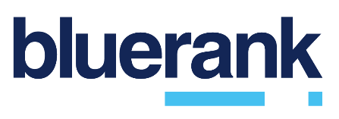

About Bluerank
Bluerank is a business partner of the biggest companies in Poland and abroad, providing services of creating and carrying out online marketing strategies. We specialize in SEO, PPC, Programmatic, Media Buying, Social Media, Digital Strategy, and R&D in three areas: services, technology, and consulting. Bluerank is carrying out marketing projects for more than 100 clients from six continents. We have won the trust of Orange, Bank Polski, Mitsubishi Motors, Porta, Unilever Food Solutions, Rainbow, Rajapack, among others.
We provide You, our Partners, with solutions that help your clients make the best buying decisions online.

