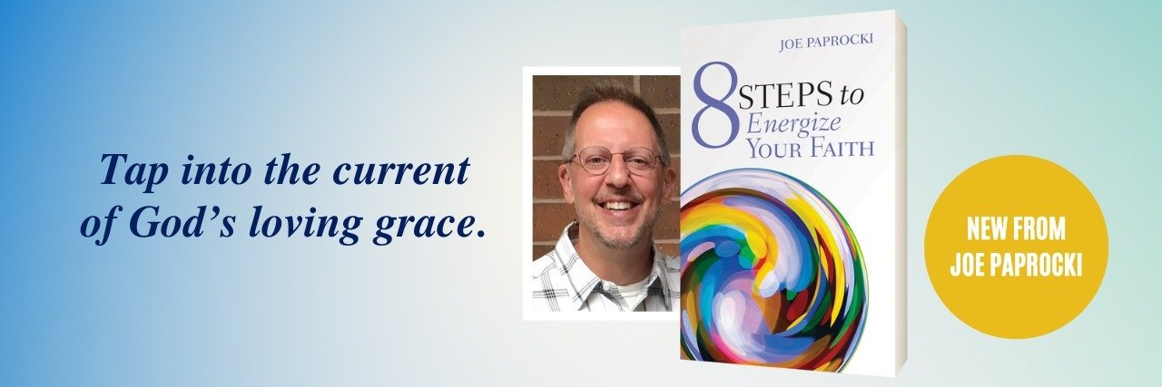

Breaking down the artificial separation between the “sacred” and the “secular” to tap into Divine energy

FOR IMMEDIATE RELEASE

Contact: Polly King, Publicist | publicist@loyolapress.com

CHICAGO, January 20, 2023 — In his new book 8 Steps to Energize Your Faith, prolific author, nationally-recognized speaker, and popular blogger Joe Paprocki, DMin, gives readers 8 decidedly “non-churchy” ways to reawaken faith and deepen one’s relationship with God.

The new book builds on the focus of Paprocki’s 40-year pastoral ministry, which has been devoted to helping people experience the nearness and accessibility of God in their everyday lives. “I want people to know that they can grow close to God without feeling as if they must become monks, holy-rollers, or theologians to do so,” states Paprocki.

Paprocki suggests that to tap into Divine energy and live a life of joy and purpose, we must emulate God’s way of proceeding as identified in Scripture. To emulate God’s attributes, he recommends that readers:

- Create something.
- Delight in nature and all of creation.
- Simplify your life.
- Build and celebrate relationships.
- Show compassion.
- Make repairs.
- Share generously and selflessly.
- Be still.

Paprocki wrote 8 Steps to Energize Your Faith to combat discouragement, disconnection and doubt, and the spiritual lethargy that has manifested itself in recent years. 8 Steps to Energize Your Faith focuses on realizing the presence of God in everyday life—in all things, people, and creation. “It is in our daily living that we need to focus our attention,” states Paprocki. “It is in daily living that the energy and direction of God need to take hold.”

Each chapter includes useful tips to put the 8 steps into practice and includes reflection exercises, with space for jotting down thoughts or ideas. 8 Steps to Energize Your Faith can be used by individuals as a way to refresh, reawaken, or awaken faith and is also useful for parish group discussion or study.

About the Author

Joe Paprocki, DMin, has served as National Consultant for Faith Formation at Loyola Press since 2002. Joe, who has over 40 years of experience in pastoral ministry, has authored over 20 books on catechesis and pastoral ministry and has presented in over 150 dioceses in North America. Joe received his Masters of Pastoral Studies from the Institute of Pastoral Studies/Loyola University of Chicago and his Doctor of Ministry from the University of St. Mary of the Lake/Mundelein Seminary. He blogs about his catechetical experiences and insights at www.catechistsjourney.com. Joe and his wife Joanne live just outside of Chicago, where they now enjoy life as grandparents.

About Loyola Press

An apostolate of the USA Midwest Province of the Society of Jesus, Loyola Press embraces the Jesuit passion for helping people find God in all things. We continue the Jesuit tradition of excellence and service by providing inspiring content for children and adults and by being people for others.

To request a review copy or to arrange interviews with Joe Paprocki, contact Polly King, Loyola Press Publicist: publicist@loyolapress.com.

Follow Loyola Press on Facebook, Twitter, Instagram, LinkedIn, Pinterest, and YouTube.

8 Steps to Energize Your Faith

Joe Paprocki

February 6, 2023

Loyola Press | $17.99 | Paperback I ISBN 978-0-8294-5449-9

