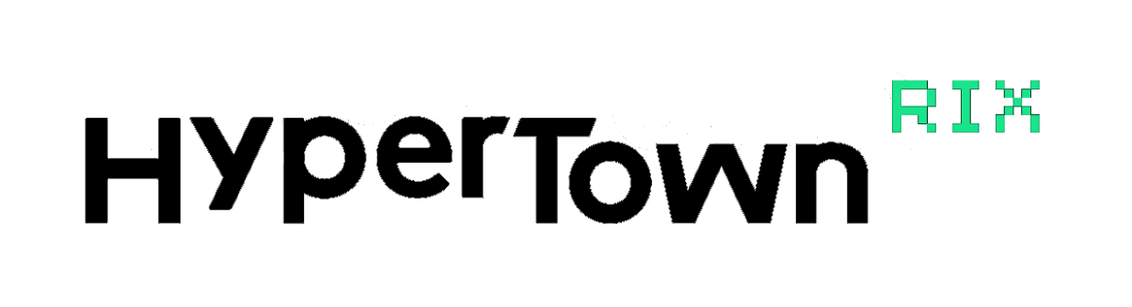
A Baltic scale event of urban culture and eSports festivities “HyperTown RIX” returns to exhibition centre “Ķīpsala” with a doubled magnitude

After a magnitude of events held in both Latvia and Estonia, the festival HyperTown is returning to Riga, bringing the visitors even more entertainment and relaxation opportunities for the entire family! For the visitors entertainment the festival brings high-end computers, robots, VR games, simulators and other exciting adventures provided by the partners of the festival, along with the finals of the Season 3 of Baltic eSports League, Cosplay showcases with most popular fantasy characters, and, for the first time in the events history – the biggest LAN Party in the Baltic States. The festival is a two-day event, taking place on June 1 and 2, 2019, in the exhibition centre “Ķīpsala”, and will occupy a space of more then 16000 m².
A variety of modern activities for the tastes of every visitor
Because of the interactive adventures and practical testing of modern entertainment technologies, the festival “HyperTown RIX” will bring an unforgettable experience for visitors of all ages. The visitors will have a chance to try their hands at controlling and even building a robot, as well as playing their favoured video game on the highest resolution computers. In addition, they will be able to try out drift and racing simulators with built-in hydraulics, as well as laser tag games and other exciting activities.
The best eSports professionals will battle it out in the finals of the Season 3 of Baltic eSports League (www.besl.pro) competitions
The festival will also host the competitions of the top Baltic eSports league (BESL), and will welcome 12 best Baltic eSports teams, participating in the game disciplines of “Counter Strike”, “Rocket League” and “PUBG” (Playerunknown’s Battlegrounds). In front of more then 1000 viewers, the finalists will fight their way towards receiving a winners trophy and a part of 15000 EUR prize money. Impressive light and sound effect shows, as well as huge screens and professional eSports commentators will sustain a dynamic atmosphere throughout the entire competition.
Cosplay – the showcase of the most popular fantasy characters
Cosplay is a form of performing art, where the artists themselves create costumes, allowing them to become characters from motion pictures, books or video games, and act out a scene from the visual life of their particular character. “HyperTown RIX” brings you the competition of more than 100 artist from the Baltic States, who will try to impress the viewers of the show with colourful and eye-catching costumes and performances. The participants of this unusual fashion competition will be judged by worldwide popular Cosplay costume artists, who are the most respected champions of the field.
Most popular Latvian influencers
“HyperTown RIX” brings together the most popular Latvian influencers on YouTube, Instagram, Facebook and other social platforms, who will share their experiences on creating an interesting and successful internet materials. It will be a great opportunity to ask question, meet and take picture with your idols.
LAN Party
For 48 straight hours video game fans will have a chance to participate in the biggest BYOC (Bring Your Own Computer) LAN Party event in the Baltic States. Each participant can chose whether to play with friends or participate in different tournaments. The BYOC event will be held in a separate hall, capable of containing up to 800 players.

Baltic scale urban culture and eSports festival “HyperTown RIX” will take place from June 1 to June 2, 2019 in the exhibition centre “Ķīpsala”. The entry tickets are available for pre-purchase online until March 17,2019 on web site www.hypertown.pro. The price for pre-purchased two-day tickets is 20,00 EUR, and 16,00 EUR for pre-purchased one-day tickets. Friend, acquaintance and work associate ticket prices are especially friendly. The festival is brought to you in cooperation with Helio, Acer, GameInsight, Samsung, Swedbank, Red Bull and Goexanimo.

“Participation in large gaming conventions is one of the best ways to reach a wide range of players. Furthermore, it is a great opportunity to present high-end equipment for virtual game fans and give players opportunities to test devices before buying them. In addition, thanks to such events as HyperTown RIX, we can put our top machines into the hands of players.” - Ingars Folkmanis, Business Manager at Acer.

Information prepared and distributed by
“HyperTown RIX” marketing specialist
Katya Rastopcina
E-mail: katya@goexanimo.lv

Pre-purchasing | Until March 17, 2019
Pre-purchase of one-day ticket | €16.00
Pre- purchase of two-day ticket | €20.00
Pre-purchase of one-day family ticket (2+2)* | -
Pre-purchase of two-day family ticket (2+2) | -
Pre-purchased VIP Pass** | €65.00
Pre-purchases one-day Friend ticket (6+1) | €96.00
Pre-purchases two-day Friend ticket (6+1) | €120.00
From March 18 to May 31
One-day ticket | €21.00
Two-day ticket | €27.00
One-day Family ticket (2+2)* | €45.00
Two-day Family ticket (2+2) | €59.00
One-day Friend ticket (6+1) | €114.00
Two day Friend ticket (6+1) | €162.00
VIP Pass | €75.00
During the event – June 1 and 2
One-day ticket | €23.00
Two-day ticket | €29.00
One-day Family ticket (2+2)* | €45.00
Two-day Family ticket (2+2) | €59.00

BYOC pass *** | €45.00
*Family ticket includes 2 grown-ups and 2 children
**VIP pass grants access to the event for both days as well as a separate entrance in the event hall, a gift bag and an access to special VIP relaxation zones.
***BYOC pass includes entrance in the event for both days, as well as access to BYOC zone for 3 days (You can start settling in on May 31, 2019)

