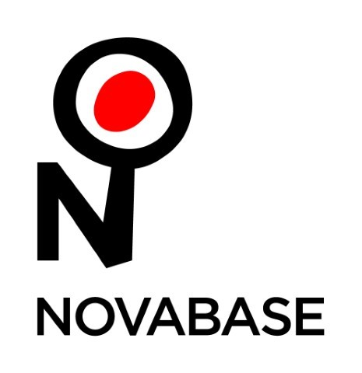

Press Release

Symetria® Recognized by the FinTech & RegTech Global Awards as an Innovative Solution

Lisbon, September 4th, 2019 – The FinTech & RegTech Global Awards recognized Symetria® as the best reporting and compliance data management solution. The ceremony took place today in Singapore and brings together the FinTech and RegTech communities to recognize innovation and outstanding work in banking.

In the words of João Nuno Bento, CEO of Novabase, “I am very happy and proud of my team for winning the Central Banking FinTech & RegTech Award. It is a deserved reward for all the effort they have put in Symetria® and validates our vision that regulatory reporting can be a value generator for banks if approached the right way. No bank can take regulatory compliance out of the equation. But being able to report in a quick and automated way, getting huge business value on top, is what can make an institution to stand out from the competition. When creating Symetria®, we had the vision that Financial Institutions could not only simplify but take value from regulatory reporting and that vision is materializing now. Thank you for your recognition.”

Symetria® is Novabase’s solution that aims to facilitate data reporting for banks and financial institutions. This solution integrates all data sources, allowing banks and financial institutions to report information requested by regulators in a timely and transparent manner. With reporting across multiple jurisdictions and a powerful analysis and validation tool that ensures the quality of reported data, Symetria® enables institutions to better control operational risk.

In Portugal, the solution has clients such as Novo Banco, Bankinter, Millennium BCP and BIG, among others.

About Novabase
In 30 years, Novabase became the Portuguese leader in Information Technologies, having been listed on Euronext Lisbon since 2000.
In 2018, Novabase achieved a turnover of 148 million euros and more than a half were obtained outside Portugal. It has offices in Spain, United Kingdom, United Arab Emirates, Angola, Mozambique and Portugal. It has the talent and dedication of more than 2000 employees from 17 different nationalities.
More information on www.novabase.com

NOVABASE  Marta Canário  Phone.: 21 383 63 00  marta.canario@novabase.pt | LIFT CONSULTING  Catarina Brito  Phone.: 21 466 65 00 Mobile.: 91 431 06 61  catarina.brito@lift.com.pt

