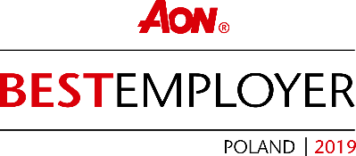
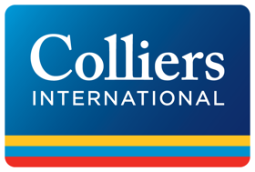

Colliers International wins Best Employer title once again

Warsaw, October 23, 2019 – Colliers International, a leading advisory company in the commercial real estate market, has once again been named Best Employer. The award is given to organisations that create the most engaging environments to work in.
The Best Employers program is one of the few competitions in which the only criterion for evaluation is the opinion of the employees themselves. Four main aspects are analysed: employee engagement, engaging leadership, business agility and orientation on people. The competition has been run around the world for 20 years by the independent company Kincentric (formerly Aon).
“The title of the Best Employer is a special distinction for us, because it comes from the evaluations of the team itself. For years, we have been working on building an engaging work environment in which everyone can develop their competences and soft skills. We have introduced numerous solutions supporting pregnant women and parents, as well as proprietary training programs for all of the company’s employees, both in our industry and many other fields, including healthy living, raising children, or coaching topics,” says Agata Błaszkiewicz, director of People Services at Colliers International.
“My dream has always been to create a work environment in which everyone feels good, which inspires and encourages creativity and development. I am glad that these efforts have been successful and appreciated by our employees. A 78% commitment level is a great result. We will certainly continue making Colliers an interesting and engaging workplace,” explains Monika Rajska-Wolińska, managing partner of Colliers International in Poland.
-- End --

About Colliers International
Colliers International (NASDAQ, TSX: CIGI) is a leading global real estate services and investment management company. With operations in 68 countries, our 14,000 enterprising people work collaboratively to provide expert advice and services to maximize the value of property for real estate occupiers, owners and investors. For more than 20 years, our experienced leadership team, owning more than 40% of our equity, have delivered industry-leading investment returns for shareholders. In 2018, corporate revenues were $2.8 billion ($3.3 billion including affiliates), with more than $26 billion of assets under management. Learn more about how we accelerate success at Colliers.com or follow us on Twitter (@Colliers_EMEA) and LinkedIn.

Colliers International has been active in the Polish market since 1997 and operates through offices in Warsaw, Kraków, Wrocław, Poznań, Gdańsk, Katowice, Łódź and Lublin with over 250 employees in total. The company has been often honored for its achievements by industry organizations such as Eurobuild, CIJ Journal, CEE Quality Awards and the International Property Awards. Colliers’ distinctions include the “Outsourcing Star”, given in recognition of its status as one of the most active real estate advisors in the outsourcing sector; and the “Gazele Biznesu” for being one of the most dynamically developing companies in Poland. More about Colliers International in Poland at Colliers.pl and our LinkedIn, Instagram, YouTube and Facebook pages.

For further information, please contact:

Sylwia Skubiszewska  Mobile +48 666 819 228  Email: sylwia.skubiszewska@colliers.com | Małgorzata Ciechanowska  Mobile: +48 882 014 424  Email: malgorzata.ciechanowska@colliers.com

