Appetite from investors for all asset classes in CEE remains positive at the end of Q3 2019, but many investors are also starting to look at alternative strategies and alternative sectors to adjust to market conditions

Colliers International presents Q3 2019 CEE Investment Scene report

Warsaw, 28 November, 2019. For the first three quarters of 2019, the CEE region has recorded an investment volume of ca. €9 billion. Offices dominate the deal flows with a 58% share, followed by a much slower retail sector with 18%, Industrial & Logistics (9%) and Hotels (8%).

Kevin Turpin, Regional Director of Research, CEE comments: “With the exception of the Czech Republic and Poland, most markets are down on Q1-Q3 volumes versus 2018 & 2017 respectively. However, with the fourth quarter of the year typically being the most active in terms of transaction closures, we expect the region to maintain a similar momentum to the previous 3 years and forecast a full year investment volume of between €12.5 and €13.5 billion.”

Appetite from investors for all asset classes in CEE remains positive, particularly as a vast amount of capital is seeking allocation and the market fundamentals in the region remain compelling. A shortage of core and core plus product can be found in some markets and sectors, as many of such properties are in the hands of long-term holders, portfolios and platforms. In addition, some owners may be hesitant to sell without the opportunity for redeploying their capital.

As a result, many investors are looking at different strategies such as value-add and opportunistic plays, plus looking into alternative sectors such as student housing, healthcare, private rental (residential), amongst others, although these are still in a relative early phase in terms of availability. More than 50% of capital deployed in the first three quarters of 2019 has come from continental Europe (incl. CEE), with 25% of the total volume coming from CEE investors alone. Asian Capital, particularly from South Korea, has also been active with a share of around 16%.

Flows by origin of capital in Q1 – Q3 2019 (%):

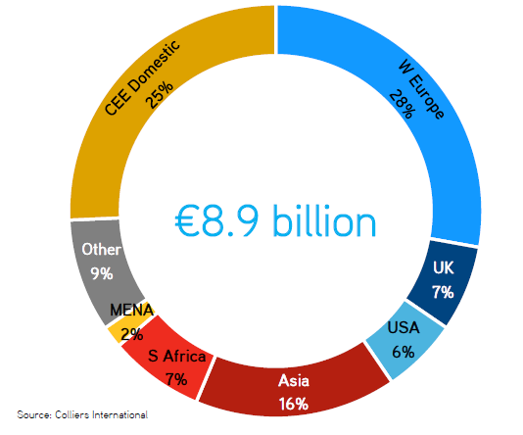

Prime yields across all countries and sectors are below, or close to, previous historical lows (pre-GFC). Despite the 375bps spread between Sofia (8.0%) and Prague (4.25%) on Prime offices, there is a further spread to similar product in Germany (3.0%) and to other, perceived, more risk averse investment vehicles, such as government bonds. Further yield compression should be limited, with a few exceptions as highlighted in the report.

***

About Colliers International
Colliers International (NASDAQ, TSX: CIGI) is a leading global real estate services and investment management company. With operations in 68 countries, our 14,000 enterprising people work collaboratively to provide expert advice and services to maximize the value of property for real estate occupiers, owners and investors. For more than 20 years, our experienced leadership team, owning more than 40% of our equity, have delivered industry-leading investment returns for shareholders. In 2018, corporate revenues were $2.8 billion ($3.3 billion including affiliates), with more than $26 billion of assets under management.
Learn more about how we accelerate success at www2.colliers.com/en-RO, Facebook, LinkedIn and Instagram.
For more information, please contact:
Aleksandra Wasilewska
PR Director, CEE/EMEA
Aleksandra.wasilewska@colliers.com
Phone: +48 510 020 050

