HIGH YIELD BRACES FOR FALLEN ANGELS
FIDELITY INTERNATIONAL WHITE PAPER
- Roughly $215 billion of US debt and €100 billion of European debt is expected to be downgraded to high yield this year.
- BBB spreads indicate some complacency
- Oil sector most exposed with $90 billion at immediate risk
London, 23 April 2020: With a recession now upon us, many zombie companies are at risk of being downgraded into high yield and becoming fallen angels.
A new white paper released today by Fidelity International - Downgrade risks when zombies become fallen angels - explores the impact of zombie companies - firms that show little signs of life but manage to survive thanks to cheap borrowing costs - being downgraded to high yield and highlights the sectors most at risk.
Roughly $215 billion of US debt and €100 billion of European debt is expected to be downgraded to high yield this year.¹ The face value of bonds rated BBB has grown steadily since the financial crisis and faster than the high yield market. In the US, the amount of BBB3-rated bonds outstanding now equals around 70 per cent of the entire US high yield market.
Chart 1: The sheer size of potential fallen angels could overwhelm the US high yield market
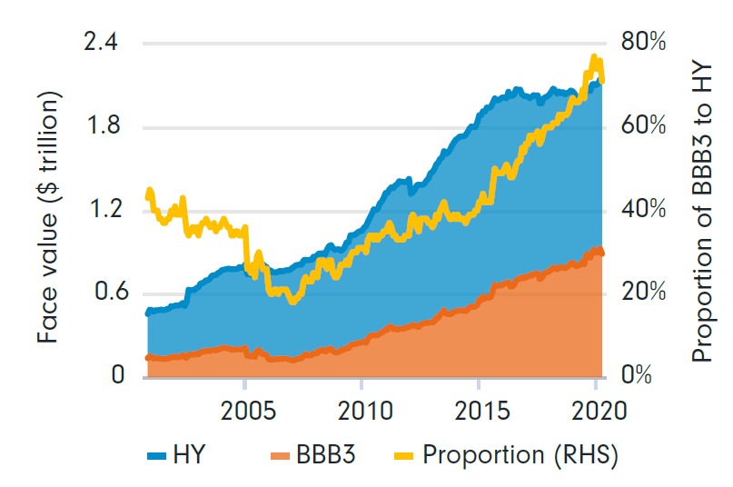
Source: IIndices: H0A1, C0A4. Source: Bloomberg, Fidelity International, April 2020.
Martin Dropkin, Global Head of Research, Fixed Income, Fidelity International, comments: “The twin shocks to the global economy of the Covid-19 outbreak and the sharp oil price decline have resonated through all asset classes. The high yield bond market must now contend with a third potential shock - an influx of downgraded investment grade bonds.
“This has significant implications for a global high yield market already reeling from the abrupt economic downturn.”
In the last month, the difference between the spreads of BBB and BB-rated bonds in the US corporate indices has risen to 273 basis points. This partially reflects the overall performance of respective benchmarks, but Fidelity believes the BB spreads are also anticipating an influx of fallen angels into the high yield index.
Fallen angels, which will largely move from BBB to BB, will swell the size of the BB category in the index, forcing managers of both passive and active strategies to reallocate from riskier categories to maintain benchmark constraints.
While spreads from potential fallen angels’ bonds already have downgrades priced in, analysis by Fidelity reveals that only around 5 per cent of the US investment grade index is currently trading at spreads equal to or wider than comparable BB-rated bonds. Considering around 27 per cent of the index is rated as BBB2 or BBB3 - the categories most at risk of a downgrade to high yield - this looks a little complacent considering the near-instantaneous stop to economic activity in some sectors.
Commenting on how to navigate the fallen angel risk Dropkin said: “As we move through this crisis, more zombies will be flushed out and market stresses will begin to dissipate. In the meantime, a good way to navigate the heightened downgrade risk is to run detailed liquidity and covenant analysis on weaker companies to determine how long they can survive without additional funding while access to liquidity remains limited.
“Despite these risks, we believe investment grade bonds are currently trading at very attractive levels, with US bonds especially well positioned. Within the BBB category, however, thorough research is needed to understand those issuers most at risk from being moved into high yield. High degree of caution is also necessary at the riskier end of the high yield spectrum (CCC/B). Credit selection here is paramount.”
Sectors most at risk of downgrades
The energy sector is most at risk of downgrades, being at the epicentre of both the oil glut and the demand shock from Covid-19. Around $60 billion of investment grade debt at the upstream end of the energy market has already been downgraded to high yield, out of around $90 billion at immediate risk. Despite the already sizeable numbers involved, there is scope for more downgrades if the oil price stays low.
The autos sector headed into the coronavirus outbreak in a weak position. Ford recently became the largest ever fallen angel as a direct result of the current crisis. Several more issuers in the sector are at risk of crossing into high yield, and the aggregate face value of downgrades could be large if S&P becomes more aggressive with its rating actions.

About Fidelity International

Fidelity International offers investment solutions and services and retirement expertise to more than 2.4 million customers globally. As a privately-held, purpose-driven company with a 50-year heritage, we think generationally and invest for the long term. Operating in more than 25 countries and with $582 billion in total assets, our clients range from central banks, sovereign wealth funds, large corporates, financial institutions, insurers and wealth managers, to private individuals.

Our Workplace & Personal Financial Health business provides individuals, advisers and employers with access to world-class investment choices, third-party solutions, administration services and pension guidance. Together with our Investment Solutions & Services business, we invest $448 billion on behalf of our clients. By combining our asset management expertise with our solutions for workplace and personal investing, we work together to build better financial futures. Data as at 31 December 2019. Read more at fidelityinternational.com

Fidelity only offers information on products and services and does not provide investment advice based on individual circumstances, other than when specifically stipulated by an appropriately authorised firm, in a formal communication with the client.
Fidelity International refers to the group of companies which form the global investment management organisation that provides information on products and services in designated jurisdictions outside of North America. This communication is not directed at, and must not be acted upon by persons inside the United States and is otherwise only directed at persons residing in jurisdictions where the relevant funds are authorised for distribution or where no such authorisation is required.
Unless otherwise stated all products and services are provided by Fidelity International, and all views expressed are those of Fidelity International. Fidelity, Fidelity International, the Fidelity International logo and F symbol are registered trademarks of FIL Limited.
Investors should note that the views expressed may no longer be current and may have already been acted upon.
Issued by Financial Administration Services Limited, authorised and regulated by the Financial Conduct Authority.
Past performance is not a reliable indicator of future returns
There is a risk that the issuers of bonds may not be able to repay the money they have borrowed or make interest payments. When interest rates rise, bonds may fall in value. Rising interest rates may cause the value of your investment to fall.
Reference to specific securities should not be construed as a recommendation to buy or sell these securities and is included for the purposes of illustration only. CC20/28

