CEE is catching up to the Western countries in terms of production

Warsaw, July 10, 2020 - Since 2004 the CEE-6’s share in EU manufacturing output has more than doubled, as measured by the output of its factories, with the region overtaking Spain and the UK, and is closing in on France - reveals Colliers International in its latest report ”COVID-19 & CEE’s Industrial Upside. Europe’s Near Shore Powerhouse”.

CEE’s highly skilled and lower cost workforce, it’s well established track record and competitiveness in industrial production coupled with the fact that the region has enabled manufacturers to generate higher levels of economic output at disproportionately lower operating costs is a compelling case for continued FDI into the region.

Labour markets in the CEE-6
Salaries in the CEE region are several times smaller than in Western Europe and, as of recent years, surprisingly comparable to markets such as China.
Silviu Pop, Head of Research, Romania explains: “As for the level of labour costs for manufacturing operations Romania is now comparable to China. Poland and Hungary are not significantly higher while Bulgaria remains well below this level. This is not to say that these markets compare in terms of critical mass, diversity of products and peak output complexity but from a cost and geographical (near-shoring) perspective, there is certainly some upside to be found in the CEE region”.
Kevin Turpin, Regional Director of Research | CEE adds: “To put things into a different context, labour costs in Germany for manufacturing are around 3 times higher than in the Czech Republic and Slovakia, around 4 times above Hungary’s and Poland’s, nearly 6 times above Romania’s and almost 8 times above Bulgaria’s”.
Productivity has more than kept up with this increase in salaries. In all CEE countries, the gap between value added per employee and labour costs has actually widened significantly between 2004 and 2018. It is worth noting that Romania’s spread between value added per employee and labour costs is just a fraction below China’s, with the other CEE markets trailing not too far behind.
Manufacturing Value Added
The region has overtaken Spain and the UK, as measured by the output of its factories, and is closing in on France. While CEE’s factories were initially focused on churning out goods involving low-complexity manufacturing processes, this has also changed gradually over time: the medium-high and high technology value added goods now make up a much higher share throughout the CEE than a decade ago.

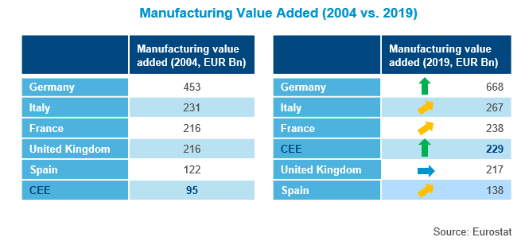
EU rules and funds push reforms in the region
According to the World Economic Forum’s competitiveness indicators for 2010 and 2019, the CEE’s average score for their infrastructure in 2010 stood at 63% of Germany’s, though after constant improvements and massive investments by CEE states, it reached 86% last year. Likewise, the institutional strength score improved from 68% of Germany’s level in 2010 to 79% last year. Looking at the average for high income countries (which the CEE region as a whole is quite far apart from), its competitiveness indicators look even better.
Despite many great things coming out of the region, according to the WEF, innovation remains the CEE’s Achilles heel, scoring almost half of Germany, which is nevertheless, one of the world’s top innovators.

The report can be downloaded from the Colliers International website here.

- End -

About Colliers International
Colliers International (NASDAQ, TSX: CIGI) is a leading real estate professional services and investment management company. With operations in 68 countries, our more than 15,000 enterprising professionals work collaboratively to provide expert advice to maximize the value of property for real estate occupiers, owners and investors. For more than 25 years, our experienced leadership, owning approximately 40% of our equity, has delivered compound annual investment returns of almost 20% for shareholders. In 2019, corporate revenues were more than $3.0 billion ($3.5 billion including affiliates), with $33 billion of assets under management in our investment management segment. Learn more about how we accelerate success at corporate.colliers.com, Twitter @Colliers or LinkedIn.

Colliers International has been active in the Polish market since 1997 and operates through offices in Warsaw, Kraków, Wrocław, Poznań, Gdańsk, Katowice, Łódź and Lublin with 300 employees in total. The company has been often honored for its achievements by industry organizations such as Eurobuild, CIJ Journal, CEE Quality Awards and the International Property Awards. Colliers’ distinctions include the “Outsourcing Star”, given in recognition of its status as one of the most active real estate advisors in the outsourcing sector; and the “Gazele Biznesu” for being one of the most dynamically developing companies in Poland. More about Colliers International in Poland at Colliers.pl and our LinkedIn, Instagram, YouTube and Facebook pages.

For further information, please contact:

Sylwia Skubiszewska  Mobile +48 666 819 228  Email: sylwia.skubiszewska@colliers.com | Małgorzata Ciechanowska  Mobile: +48 882 014 424  Email: malgorzata.ciechanowska@colliers.com

