CEE Investment volumes for the first half of 2020 have increased year on year by 7%

Warsaw, August 18, 2020 – CEE Investment volumes for the first half of 2020 reached ca. € 6.26 billion. This figure was boosted by 2 large portfolios totalling in excess of €2.2 billion, with Poland and the Czech Republic taking a 78% share of the CEE-6 total - reveals Colliers International in its latest “H1 CEE Investment Scene” report.
The large residential portfolio transaction by Heimstaden represents 67% of the total volume traded in the Czech Republic and ca. 21% of total volumes. The acquisition of the 61.5% GTC shares from Lonestar by Optima across CEE represents 15% of total CEE6 volumes.
Aside from the large residential portfolio traded, the Office and the Industrial & Logistics sectors both performed well with 41% and 22% of the volumes.
“Unsurprisingly, the Retail and Hotel sectors remained somewhat more limited in activity, being among the hardest hit sectors by the pandemic. In terms of pricing, Prime Industrial and Logistics yields have remained stable, with some compression in select markets. Prime Office yields have moved out on average by 25 bps while prime retail has moved by 50 bps. Investor appetite remains strong for CEE but a cautious approach is still being applied while markets try to settle and travel restrictions still apply from some parts of the globe”, says Kevin Turpin, Regional Director of Research | CEE at Colliers International.
EMEA investors (excluding CEE) have been the most active during H1 2020, particularly Sweden with the large €1.3 billion Czech residential portfolio, followed by German and French capital, each with ca. €250 million of acquisitions. As in previous years, CEE domestic capital was also very active securing a third of all volumes.
The report can be downloaded from the Colliers International website here.

CEE Investment Volumes by Country 2016–H1 2020 (€ billion)

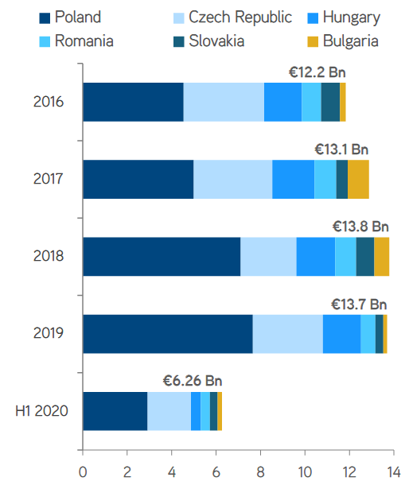
-- End --

About Colliers International
Colliers International (NASDAQ, TSX: CIGI) is a leading real estate professional services and investment management company. With operations in 68 countries, our more than 15,000 enterprising professionals work collaboratively to provide expert advice to maximize the value of property for real estate occupiers, owners and investors. For more than 25 years, our experienced leadership, owning approximately 40% of our equity, has delivered compound annual investment returns of almost 20% for shareholders. In 2019, corporate revenues were more than $3.0 billion ($3.5 billion including affiliates), with $33 billion of assets under management in our investment management segment. Learn more about how we accelerate success at corporate.colliers.com, Twitter @Colliers or LinkedIn.

Colliers International has been active in the Polish market since 1997 and operates through offices in Warsaw, Kraków, Wrocław, Poznań, Gdańsk, Katowice, Łódź and Lublin with 300 employees in total. The company has been often honored for its achievements by industry organizations such as Eurobuild, CIJ Journal, CEE Quality Awards and the International Property Awards. Colliers’ distinctions include the “Outsourcing Star”, given in recognition of its status as one of the most active real estate advisors in the outsourcing sector; and the “Gazele Biznesu” for being one of the most dynamically developing companies in Poland. More about Colliers International in Poland at Colliers.pl and our LinkedIn, Instagram, YouTube and Facebook pages.

For further information, please contact:

Sylwia Skubiszewska  Mobile +48 666 819 228  Email: sylwia.skubiszewska@colliers.com | Małgorzata Ciechanowska  Mobile: +48 882 014 424  Email: malgorzata.ciechanowska@colliers.com

