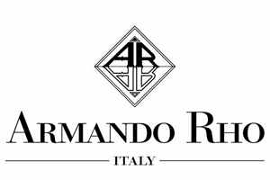

Spaces of refined conviviality

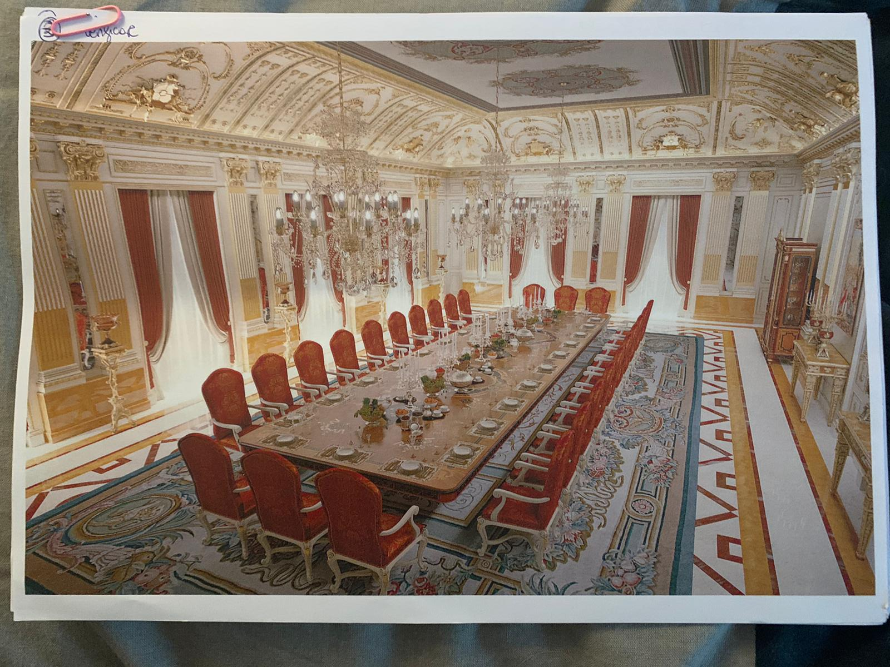

In a mansion with classic taste, Armando Rho designs a majestic dining room in French style where refined details dominate the scene.
The table, enriched with exquisite inlays, stands out in the middle of the room and is surrounded by upholstered armchairs in silk damask. Particularly evocative, the large table is made with precious wood species, such as the rare Persian walnut-burl, enhanced by refined mother of pearl inlays.
This table is a piece of the rich Armando Rho’s collection, but in this project it is customized according to the Client's needs as confirmation of the high degree of flexibility of the Company.
The ivory-lacquered boiserie makes this space even richer and imposing, also thanks to the presence of many carved details in gold leaf finishing, such as capitals, friezes and grooves.
The ceiling hosts a painting of classical inspiration and creates a bright space surrounded by a crown of carved and gilded curved panels, a true masterpiece of precision and technical ability, that is produced and then installed by skilled workers. Functionality combined to comfort for a space devoted to representation and conviviality.

ARMANDO RHO S.R.L
Via Per Cabiate, 111, 22066 Mariano Comense CO
Ph. +39 031 747463
www.rhoarmando.com - info@rhoarmando.com

OGS SRL PUBLIC RELATIONS & COMMUNICATION
Via Koristka 3, 20154 Milano, (Italy)
Ph. +39 023450610
www.ogscommunication.com- info@ogscommunication.com

