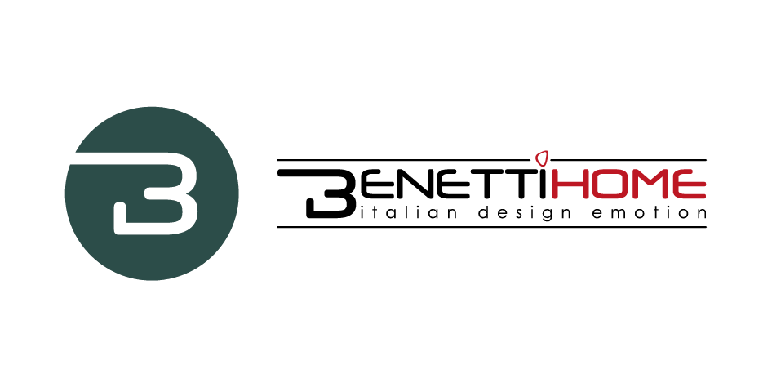
BENETTI HOME
TALKING ABOUT VERTICAL GARDENS AT THE MUSTELA ITALIA OFFICES

At the offices of Mustela, French company specialized in products for babies, an informal chat between professionals, design experts and enthusiasts of vertical gardens took place, involving interior designer Luca Medici, the CEO of Benetti Home Stivens Benetti, Rosanna Re of the Sales Division of Benetti Home, and the Business Development Strategist Michela Muntean.

The goal was ‘talking about something beautiful’. And greenery generates beauty, wellness, and serenity. The conversation starts with the interiors of the location designed by Luca Medici who showed the concept: open, friendly spaces, designed to include green walls and impactful sustainable concepts to convey Mustela company culture to the interiors since the company has always been focused on sustainability.

The solution was to apply at different spaces the Benetti MOSS which is a stabilized, natural and maintenance-free lichen: it was used for the kitchenette and break area, up to the entrance to frame the company logo. Luca Medici is excited about the logo: “It’s easy to use and to remove, place and shape for different intended uses”. The aesthetic impact of the green element is the focus of the project and therefore the project will become a model for other international headquarters of the company in the world.

Another important topic discussed was the multi-sensoriality linked to greenery. The different professionals talked about the sensory positive effects of Benetti MOSS: the color is eye-catching; it is pleasant to touch and it releases a lovely moss scent. There is even the sound involved. In 2021, in fact, among its latest projects, Benetti Home has launched BenettiSOUND, a vertical garden in 100% natural, stabilized lichen with a high-tech sound system that allow the wall to sound, providing a total multi-sensorial experience.

Michela Muntean defined greenery as “very inspiring and interesting” talking about its application to the exhibition industry where people can touch the product and interact with the it. In fact, it is important to engage and experience. Looking without touching and experiencing the product is a real disadvantage, especially in trade fairs. “Talking about the concept of experiencing the product, it could be interesting to include more small user-friendly, green design elements or do-it-yourself objects to help people to experience greenery with simplicity and engagement. Especially in your home, which becomes the center of our daily life, greenery can help to create a corner of wellbeing, a place where you can feel good. Even aseptic and sterile environments, such as hospitals and pharmacies, which greenery can make cozy and comfortable for patients and clients”.
“It’s a very flexible product for many uses”, as explains Rosanna Re, “Architects and designers show us ideas about the most imaginative and unique custom projects. The idea of a client can lead to an interesting project which can become a collection. Some examples are Benetti H(AIR) and Benetti SKY: Benetti H(AIR) is an anthracite iron structure covered with natural stabilized foliage of Amanthus, available in three different diameters which combine to create a dynamic ceiling; whereas Benetti SKY is composed of an iron structure covered with natural stabilized foliage to apply, in particular, to meeting rooms because of its sound-absorbing properties which assure the necessary privacy to business meetings”. In conclusion, it is a product with many features. You can cut, process or transform it. Only imagination is the limit.
Many ideas came up during the talk and these experiences teach us that synergies make a difference. Only through a passionate discussion new ideas and successful projects can be developed.

Benetti Home
Via Giacomo Matteotti, 34, 28060 Granozzo NO
info@benettihome.com - www.benettihome.it

OGS PR and Communication
Via Koristka 3, Milano
+39 02 3450610
www.ogscommunication.com- info@ogscommunication.com

