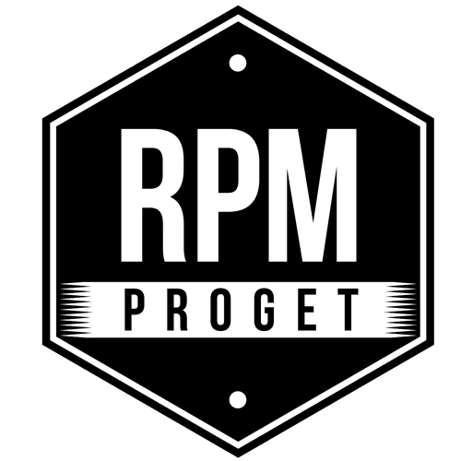

ACOUSTIC COMFORT IS ON STAGE AT THE NEKO RESTAURANT
IN ROME

Having as starting point the multifaceted and dynamic reality of Rome, the activity of RPM Proget Studio extended to other cities in Europe and the United States, with a significant experience of great commitment and satisfaction in Miami, Florida.

Alongside the great originality of proposals, where a strong aesthetic sign combines with the pleasantness of the vintage atmosphere and the functionality of the creations, RPM Proget Studio pays particular attention to the technical aspects and to those related to sustainability.

NEKO restaurant in via Aosta in Rome is a project from RPM Proget featuring a particular relevance from the point of view of the coatings, as it used Caparol paint, a very strong product able to withstand impact with objects, such as that of chairs against the walls, a very common situation in a restaurant. The aesthetic result of this choice is excellent and a truly competitive one, even from an economic point of view.

A priority role was also reserved for the theme of acoustics. Soundproofing tests were carried out in the NEKO restaurant, which sees a combination of materials and furnishing solutions, where the use of natural elements is associated with the use of technical materials.

In terms of acoustics, the Caparol paint is able to guarantee an excellent level of soundproofing of the premises. “In this regard – as the Studio’s team points out - it should be emphasized that acoustic comfort in restaurants is a much more important issue than usually considered. Staying in a crowded environment with high sound diffusion levels can be very unpleasant. In particular, in the NEKO restaurant project, we used Caparol paint, which combines three winning requirements: aesthetics, economy and acoustic comfort.”

It is a very materic painting, while usually for restaurants a smooth and glazed paint is used to give an effect of greater shine. In this case, Caparol gives a muffled acoustic sensation, without losing any of the desired aesthetic results. In the background, a green wall made with real plants put vertically on a wall-mounted tub system is ideal for this purpose, as it helps to lower the propagation of noise while giving the pleasure and relaxation of a corner of nature in the room.

A particular piece of furniture, which cannot be missed by the observer, is the dazzling blue counter, a strong and pleasant aesthetic sign, as well as the use of wallpaper, certainly not usual in this type of spaces, but precisely for this reason particularly amazing and original.

"Knowing the place, listening carefully and understanding the customer's needs, working with a 'handicraft' approach paying attention to details to create unique suggestions and

atmospheres, are fundamental issues - says the Studio team – and go hand in hand with the food experience.”

All in all, the guidelines of the design project for NEKO restaurant resulted in a fresh and innovative location with large windows directly overlooking Via Aosta and generating a strong and attractive impact.

RPM PROGET
Via Gregorio VII, 472, 00165 Roma
www.rpmproget.it/ - info@rpmproget.it
+39 06 66019011

OGS PR and Communication
Via Koristka 3, Milano
www.ogscommunication.com – info@ogscommunication.com
+39 02 3450610

