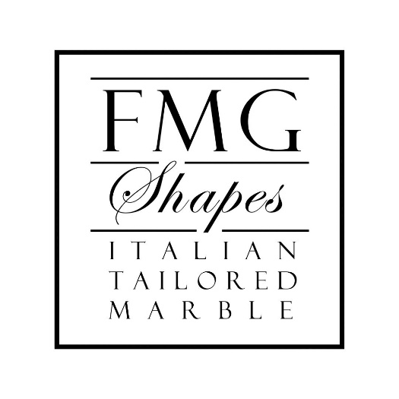

FMG SHAPES. CHINESE CULTURE TRANSPOSED TO MARBLE IN A COMPLEX OF VILLAS IN SHANDU

Shandu is a fast-growing Chinese town, near the city of Shenzhen, in the south of the country. The complex of four villas redesigned by FMG Shapes with high-end materials, belongs to a successful entrepreneur who, as is a tradition in China, wanted to manifest the affective bond to his own place of origin by constructing in Shandu these buildings of great architectural prestige, while keeping his own residence in Honk Kong.

Interpreter of Italian luxury in the field of marble and high prestige stone materials, FMG Shapes company in Chiampo takes its roots from the ancient marble tradition present in the Italian valleys of Vicentino and is now in its third generation with the brothers Daniele and Simone Farinon.
An ideal partner for the design, production, shipping and installation of highly complex and luxury custom projects for large, residential and retail, FMG Shapes completed this significant project in China in January 2020 in in a very short time frame.

The main villa is part of a complex of four buildings, one of which is for the owner’s son and two for his grandchildren. The works of the two main villas were directly managed from Italy, while the other two were mainly carried out in China.

The main villa covers an area of 2500 square meters, covered with prestigious materials, filled with decorative objects and structured on six levels. A large spiral staircase climbs up all levels from the ground floor to the sixth floor and is filled with all the decorative elements of traditional Chinese culture and the presence of devotional altars. A relevant space is reserved for kitchens: they are numerous and important in the villa, both from a technical and aesthetical point of view. There are professional steel kitchens for food preparation and others of façade, mainly for decoration. Equally important is the space reserved for other domestic environments, which range from monumental dining rooms to luxurious rooms.

The prestigious materials chosen by FMG Shapes were used exclusively for the interior finishes and were chosen inspired by the colors of classical Chinese tradition, white and light blue. The references to Chinese culture are strong and, as a chromatic tribute to this world and its traditions, white marbles from Carrara and Greece, light blue stones from Bolivia and Brazil have been used, all very prestigious, as is the characteristic of blue stones, which are the expression of refined luxury.

The Calacatta marble comes from Italy, the classic Venus White and Bianco Sivec from Greece and Macedonia, the Sodalite boliviana and Azul Macauba from Brazil, without forgetting the precious Agata azzura, which are classic jewelry stones, usually used in this context or transferred in the world of furniture.

Different shades and tones of blue have been privileged in order to reach an accentuated chromatic exaltation and a game of precious inlays, to obtain the typical effects of Chinese tradition, also through exciting contrasts with gold and yellow Siena.

“We worked – Daniele e Simone Farinon of FMG Shapes explain – with a Chinese studio which expressed a remarkable identity of design and decoration without any attempt to emulate the architectural classics of European culture with references to Corinthian, Doric or Ionic capitals. Here, proportions and decorative elements typical of Chinese culture were chosen. The characteristic of interior decoration, especially in recent years, is moving towards globalization, but enhancing what are the architectural and cultural values of each country. Surely, the Greco-Roman architecture is widespread throughout the world, but it is equally important, as in this case, the culture related to the Chinese architectural tradition, which today are made with different materials, no longer in wood as in the past, but in stone”.

This project gave priority to the representation of floral decorations: very often, in classical Chinese culture, human figures and epic moments are represented, whereas in this case, something figurative and not commemorative was chosen and the motifs are really stylized, with precise references to one of the greatest Chinese decorative traditions, that of the vases of the Ming era.

The dialogue with the commission and the designers was fluid and intense. From a production point of view, all the productive and technical phases were followed directly by FMG Shapes which optimally managed all the phases from Italy.

FMG Shapes – quality and design in the marble and stones craftsmanship

FMG SHAPES
Via Fabbrica, 4
36072 – Chiampo – VI – ITALy
Instagram: fmg_shapes
Linkedin: FMG Shapes - Italian Luxury Marbles

For press inquiries, custom interviews:
OGS PR and Communication
Via Koristka 3, Milan | Italy
ph. +39 02 3450610
info@ogscommunication.com
www.ogscommunication.com

