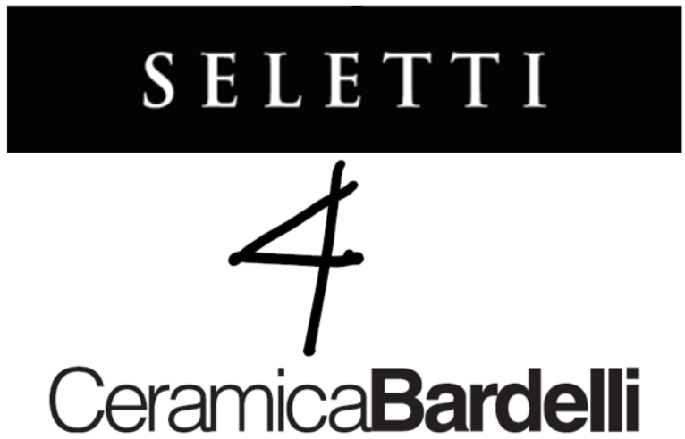

TILES (R) EVOLUTION

Seletti 4 Ceramica Bardelli is the art meeting the matter

Seletti 4 Ceramica Bardelli is the result of a collaboration between Seletti’s figurative design and Ceramica Bardelli’s expertise in ceramics. The outcome is the capsule collection Tiles (R)evolution which consists of floor and wall tiles with high impact aesthetic proposals designed for the house, contract and hotel industry.

This unprecedented artistic collaboration, which represents a revolution in the world of decorative surfaces, brings together two Italian excellences: the technological innovation and the formal and aesthetic research of the Ceramica Bardelli Group, and the disruptive approach to interior design of Seletti.

“The meeting with Stefano Seletti is the realization of a dream, that is the creation of a 2D capsule collection with the typically 3D aesthetic and design to dialogue with the world of architecture with an original language, Gianmaria Bardelli says. Our common objective? To overturn the logic of decoration and modern creation and go beyond the schemes! In this way, we open together the door to (R)evolution in the design and world of ceramics!”

“There is one thing that Seletti undoubtedly does not lack: the enthusiasm to experiment. In fact, when GianMaria Bardelli proposed me to imagine a project together, I immediately accepted”, says Stefano Seletti, the company’s artistic director. “I discovered that the world of surfaces has something magical in its proposal, with a potential partly close to that of art”.

The collection, made of high-quality materials, is composed of five lines – Distorsion, Diamond, Black&White, Elements 1 - Nuvole and Elements 2 - Acqua – that translate into an unconventional pattern with a contemporary soul to create engaging and surprising spaces.

DISTORTION
Distortion is a porcelain stoneware tile - with a super-matt finish thanks to no-reflex glazes - whose patterns and geometries reinterpret Seletti's iconic black and white pattern, drawing inspiration from the imagery of Maurits Cornelis Escher and the paradoxical perspectives, hypnotic patterns, and perceptual short-circuits characteristic of his works.
Distortion is ideal for floor applications in which the optical effect of "distortion" is expressed to the utmost: through the combination of square modules measuring 14x14 cm and diamond-shaped modules measuring 14x24 cm - mounted on fiberglass mesh - the image of the classic checkers is thus transformed, making it possible to create an infinite variety of compositions and unexpected optical effects.

DIAMOND
Diamond is a three-dimensional monoporous ceramic tile available with a glossy finish - in white, black, orange, mustard and red - and in glass with a mirror finish in the Mirror version. The 10x40 cm size of the Diamond line makes it possible to imagine modular coverings for spaces with a contemporary soul, but also for more classic spaces, thanks to the iconic diamond pattern that evokes a retro look and vintage atmospheres.

BLACK&WHITE
Black&White is a mosaic - in single firing with a glossy and matte finish - which expresses the consolidated expertise of Ceramica Bardelli in imagining solutions that allow to overcome the traditional boundaries of decoration, combined with the visionary approach of Seletti.
The line, which is characterized by a play of black and white with infinite combinations of creativity, is available in a kit consisting of 12 sheets (each measuring 30x30 cm) that makes it possible to create a wall measuring 140x240 cm. The resulting compositions are a unique texture that allows to intervene on clear-cut shapes but also on rounded surfaces by covering them like a fabric.

ELEMENTS 1 - NUVOLE and ELEMENTS 2 - ACQUA
Elements is a series in which nature and its elements, water and clouds, are the protagonists: thanks to the large 60x120 cm format of the tiles (which can be combined with A+B patterns and are made using high added-value "third-fire" digital printing technologies), it is possible to create immersive spaces, bringing the magic of the outside world into interiors. Walking on a blue sky dotted with soft clouds or feeling surrounded by crystal-clear water thus becomes possible: perception is overturned, radically transforming interior spaces.

PRESS OFFICE BARDELLI GROUP
OGS PR and Communication
Via Koristka 3, 20154 Milan
www.ogscommunication.com
+39 02 3450610 / info@ogscommunication.com

Vittoria Vicini / ph. + 39 393 8913687 / vittoria@ogscommunication.com

PRESS OFFICE SELETTI
Paridevitale Communication & PR
Viale Vittorio Veneto 28, 20124 Milan

Italian press
Chiara Valentini / ph. +39 348 9214456 / chiara@paridevitale.com

International press
Giovanni Sgrignuoli / ph. +39 328 9686390 / giovanni@paridevitale.com

