**FIDELITY INTERNATIONAL ANALYST SURVEY: LIGHT AT THE END OF THE TUNNEL FOR CORPORATES**

* Just over half of Fidelity analysts expect the global business cycle to turn positive by the end of 2023.
* China leads in expectations for revenue growth globally, as it emerges from its zero-Covid policy
* Focus on ESG remains high for corporates, but more needs to be done on biodiversity

**Madrid, 22 Feb 2023:** Corporates faced one of their toughest years in recent history in 2022, as the global economy faced a confluence of shocks. And as we enter 2023, with higher prices and higher interest rates, businesses face another tough year ahead. But, according to Fidelity International’s annual analyst survey, there is light at the end of the tunnel, with China leading the way.

Fidelity International’s annual Analyst Survey studies the views of its in-house analysts across the world, aggregating bottom-up information from c. 15,000 individual company interactions to find key trends in the corporate landscape.

According to the survey, 60 per cent of analysts believe their sectors are already in a slowdown, a shallow recession or worse. But looking ahead, just over half of those analysts expect the business cycle will have turned positive again by the end of 2023.

**Chart 1: This too shall pass**

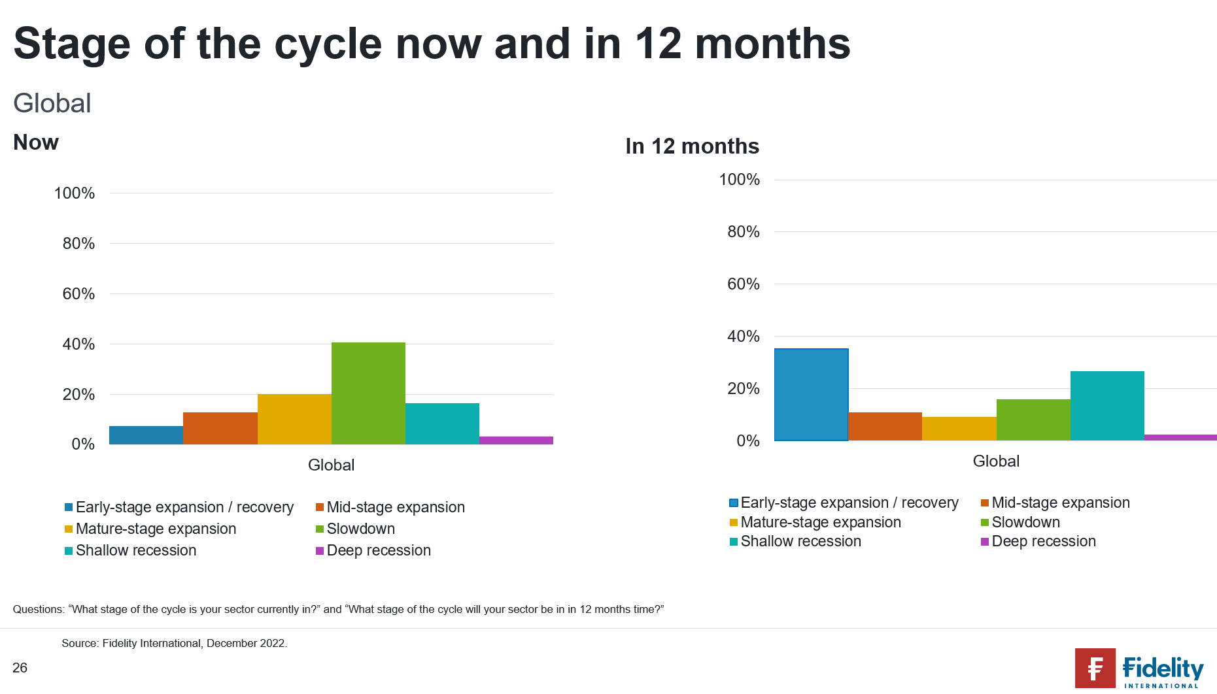

*Questions: “What stage of the cycle is your sector currently in?” and “What stage of the cycle will your sector be in in 12 months’ time?” Chart shows percentage of analysts. Source: Fidelity Analyst Survey 2023*

**Fiona O’Neill, Head of Strategic Initiatives, Global Investment Research at Fidelity International commented:** “Our survey findings may run contrary to the prevailing mood after a year in which the shocks delivered by Russia’s invasion of Ukraine have run parallel to the deflating of a decade of booming stock markets and cheap money. But from a wider perspective, it is in line with economic logic: as companies reach the bottom of the business cycle, they begin to think about the opportunities to come.”

“According to the survey, cost pressures will peak for most sectors and regions in the first half of the year. China - assuming its reopening gamble works - will reboot, and materials, utilities and technology companies will shift back into investment mode, in part driven by the environmental transition.”

**China enters expansion mode**

As China emerges from its zero-Covid policy, its economy looks to be in a different point in the business cycle. Most Fidelity analysts covering China expect to see revenue growth over the next 12 months, the highest among all regions.

**Chart 2:** **China leads in expectations for revenue growth**

*Question: “What are your expectations for revenue growth over the next 12 months?” Chart shows percentage of responses reporting expected increase in revenue. Source: Fidelity International Analyst Survey 2023.*

Adding to the bullish tone, in Fidelity’s most recent monthly surveys, which pick up shorter-term shifts in mood, China emerged as the only region Fidelity analysts reported positive sentiment among company managers for both December and January. It was in December that China started easing lockdowns and preparing for reopening.

**Chart 3: China’s reopening promise has boosted management sentiment**

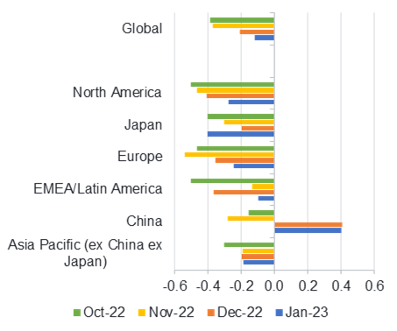

*Question: “Based on your interactions with companies over the past month, to what extent, if at all, has your perception of management sentiment over the next six months changed?” Chart shows proportion of responses reporting positive management sentiment minus those reporting negative management sentiment. Strong negative and strong positive responses receive a double weighting. Higher values show analysts are, on balance, reporting more positive sentiment among the companies they cover, lower values more negative sentiment. Source: Fidelity International Analyst Survey 2023.*

However, this optimism is tempered by concerns over a possible Covid resurgence, as China has swung from zero tolerance for infections to a fast reopening.

**Fiona O’Neill commented:** “Corporates have responded positively to the easing of China’s zero-Covid policy, with stock markets rising rapidly since December, However, companies might see a weaker near-term performance given employee absence and overall, we anticipate it could be a bumpy ride before Covid cases normalise.”

**Be prepared**

Despite cautious optimism for the year end, the pain ahead is evident in the survey’s wide range of data points. Fidelity analysts expect a rise in debt defaults over the next 12 months. Recent growth in shareholder pay-outs will fade, while M&A activity will slow, with 73 per cent of Fidelity analysts saying the deals they do expect will be smaller, bolt-on acquisitions. Around three-quarters (74 per cent) say that, for now, the biggest focus for boards is holding down costs and shoring up revenues, rather than investing for growth or delivering shareholder returns.

Geopolitics, brought sharply into focus by the Russian invasion, are also a fast-growing concern, with the survey’s negative net reading for this topic almost doubling.

**Nature calls**

**Chart 4: Companies have maintained their ESG focus**

*Question: “Has the emphasis on ESG among your companies fallen over the last 12 months?”*

Encouragingly, the vast majority (90 per cent) of Fidelity analysts report their companies are placing the same or greater emphasis on environmental, social, and governance issues (ESG) as they were a year ago. But, only 8 per cent of Fidelity analysts expect companies to reduce their negative impact on terrestrial biodiversity within the next 12 months. For oceanic biodiversity the figure is 6 per cent.

**Ned Salter, Global Head of investment research, added:** “Our survey shows, when it comes to ESG, companies are listening, and acting - but there is much work to do. Initiatives related to biodiversity are still in early stages for most companies, but a key engagement area where we want to drive forward with our investee companies this year.”

“The recent UN Biodiversity Conference in Montreal, also referred to as COP15, has [raised the profile of biodiversity](https://www.fidelityinternational.com/editorial/article/why-nature-positive-will-be-as-big-as-net-zero-9920bd-en5/) and its significance to achieving net zero, adding fresh impetus to our conversations with companies on this topic.”

**Risk warnings:**

Investors should note that the views expressed may no longer be current and may have already been acted upon.

Overseas investments will be affected by movements in currency exchange rates.

Investments in emerging markets can be more volatile than other more developed markets.

**About Fidelity International**

Fidelity International offers investment solutions and services and retirement expertise to more than 2.8 million customers globally. As a privately held, purpose-driven company with a 50-year heritage, we think generationally and invest for the long term. Operating in more than 25 countries and with $613.3 billion in total assets, our clients range from central banks, sovereign wealth funds, large corporates, financial institutions, insurers and wealth managers, to private individuals.

Our Workplace & Personal Financial Health business provides individuals, advisers and employers with access to world-class investment choices, third-party solutions, administration services and pension guidance. Together with our Investment Solutions & Services business, we invest $459.9 billion on behalf of our clients. By combining our asset management expertise with our solutions for workplace and personal investing, we work together to build better financial futures. Data as of 30 September 2022. Read more at fidelityinternational.com

Fidelity only offers information on products and services and does not provide investment advice based on individual circumstances, other than when specifically stipulated by an appropriately authorised firm, in a formal communication with the client.

Fidelity International refers to the group of companies which form the global investment management organisation that provides information on products and services in designated jurisdictions outside of North America. This communication is not directed at, and must not be acted upon by persons inside the United States and is otherwise only directed at persons residing in jurisdictions where the relevant funds are authorised for distribution or where no such authorisation is required.

Unless otherwise stated all products and services are provided by Fidelity International, and all views expressed are those of Fidelity International. Fidelity, Fidelity International, the Fidelity International logo and F symbol are registered trademarks of FIL Limited.

Portugal: Issued by FIL (Luxembourg) S.A., authorised and supervised by the CSSF (Commission de Surveillance du Secteur Financier).

CC23/09