Your house, your wealth: what happens in an era of rising rates?
UK housing is less affordable now than at any point in 147 years. But will higher interest rates be about to change all that, altering the wider role property plays in UK household wealth?
House prices in the UK are higher now than at any point since 1876, according to analysis by investment firm Schroders. This is based on measuring the average price against the average earnings.
With house prices now at 9.1 times earnings, they are the highest at any point since the Victorian era.
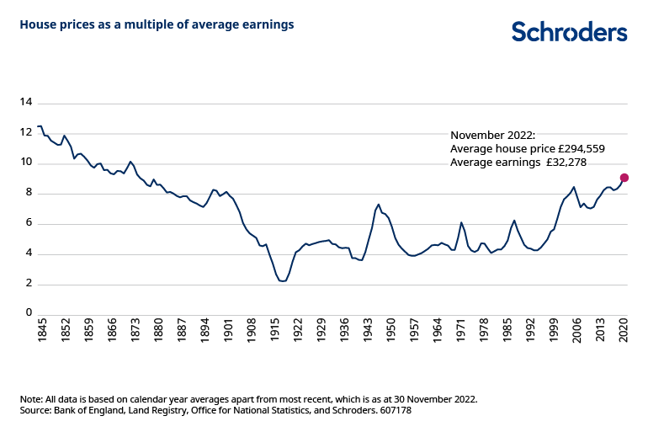

Low interest rates were key in driving up house prices for the past 40 years…
Until very recently UK interest rates were in long-term decline, reaching record lows in the years following the financial crisis in 2008- 2009. For 13 years between March 2009 and April 2022, for example, the official Bank Rate remained at or below 0.75%.
Lower borrowing rates translated into rising prices: as mortgage costs came down, someone on the same wage could afford the monthly payments on a more expensive home. In a 2019 study, the Bank of England calculated that nearly all of the rise in average house prices relative to incomes between 1985 and 2018 was a result of “a sustained, dramatic decline in real interest rates.”

…so what will happen now that rates look set to be higher, for longer?
Since late 2021 the UK’s Bank Rate has risen more than 30-fold from 0.1% to 3.5%. Some borrowers’ mortgage rates have already risen in response, but the biggest hike in mortgage costs is arguably yet to bite. This is because many borrowers have loans where rates are fixed for two, three or five years. Only at the end of those periods do they need to pay the “variable” rate or find a new deal.
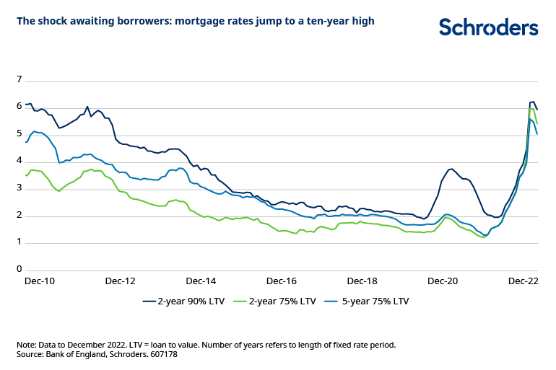

What the chart shows
The chart shows the rates of new mortgages taken out where the rates are fixed for two or five years, with a varying deposits (or equity in the property). In some cases, borrowers who have been paying a fixed rate of around 2% will reach the end of that deal and now have to pay a rate of 5% or 6%.
On a 2% mortgage rate, the monthly repayment on a £300,000 property bought with a 10% deposit and a 25 year repayment term would have been £1,144. At 6% it would be £1,740, more than 50% more. Potential homebuyers need to either find more cash, lower their expectations, or prices have to fall.
Very approximately, it would take around a 30% price decline in the example above for the monthly payments to be similar to before.

What this means for wider finances
While housing commentators already point to falling prices as borrowers adjust to bigger mortgage costs, there are other, wider implications for household wealth and financial planning.
Gillian Hepburn, Schroders’ Head of UK Intermediary Solutions, explains: “Property forms a large part of many people’s overall wealth. For younger generations with mortgages, there will be questions around meeting those higher monthly costs from existing income – and what that might mean for other outgoings including investing and pensions.
“An older generation might be mortgage-free – and arguably they have been the main beneficiaries of this long-term trend – but they too will face new decisions. These might be around options to downsize or accessing the property value in future years. The ‘bank of mum and dad’ is also one of the biggest lenders in the UK with almost half of first time buyers receiving help from parents or family.”

”Property or pension”: time to look again?
Anyone who has read the Money section of a Sunday newspaper will be familiar with the question regularly posed to celebrity interviewees: Which is better, property or pension? In all but a tiny minority of cases, the answer comes back “property”.
House prices have tended to rise in recent decades – as described above – so it is not hard to understand why people say this. £100,000 worth of UK property 25 years ago would be worth an average of around £454,000 today. This obviously varies by region. In London it would be worth around £580,000 and in Scotland, £407,000. These figures exclude any costs of ownership such as maintenance, repairs, insurance or taxes; nor any income generated by the property (not relevant for primary residence, only buy-to-let). Nor do they factor in the impact of mortgage finance or "leverage".
However, that same £100,000 invested in the global stock market (again, excluding any costs) would have grown even more, to around £631,000. This is almost 10% more than in even the best performing regional property market, London. Furthermore, it doesn’t matter whether you look at this over 5, 10, 15, 20, 25 or 30 year horizons. The stock market would always have resulted in a bigger increase in your £100,000 compared with UK residential property.
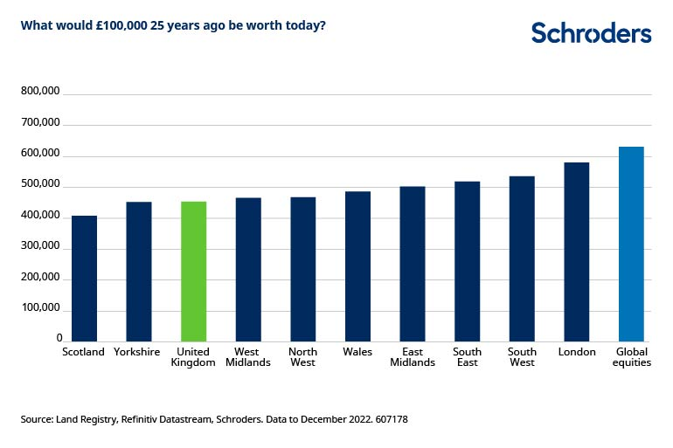Of course comparisons like this do not take into any account the substantial tax savings which can be earned by saving into a pension, nor the substantial taxes and costs associated with buying and selling property.
Duncan Lamont, Head of Strategic Research da Schroders

