Six charts that show how cheap UK equities are
How undervalued are UK equities? Let me count the ways.
Duncan Lamont, CFA, Head of Strategic Research, Schroders
Investor neglect of UK equities has pushed valuations to exceptionally cheap levels just about every way you look at them.
They look particularly undervalued relative to the US, which now makes up a dominant 68% of developed markets, as represented by the MSCI World Index. The UK has sunk to a barely 4% weight.
Private equity investors are snapping up bargains. Will public market investors start to recognise the opportunity too?
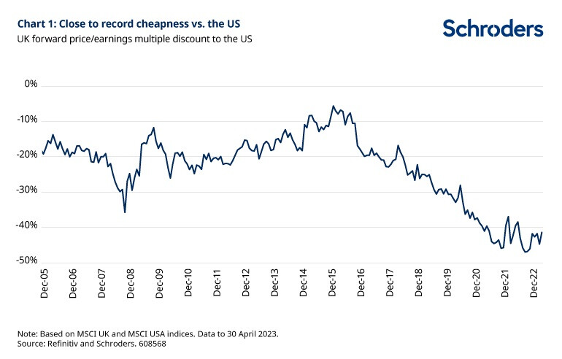
This isn’t just a US effect; the UK is also trading at a wide discount to European equities. In both cases, the gulf opened up in 2016 and, although the tide appears to have stemmed in the past couple of years, the UK still looks very cheap compared with international peers.
The forward PE is explained at the bottom of this article.
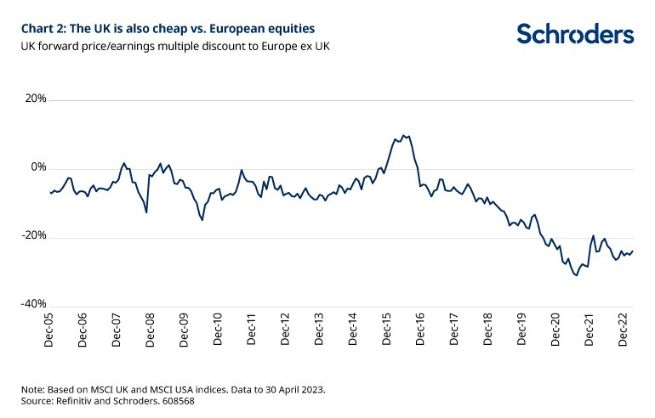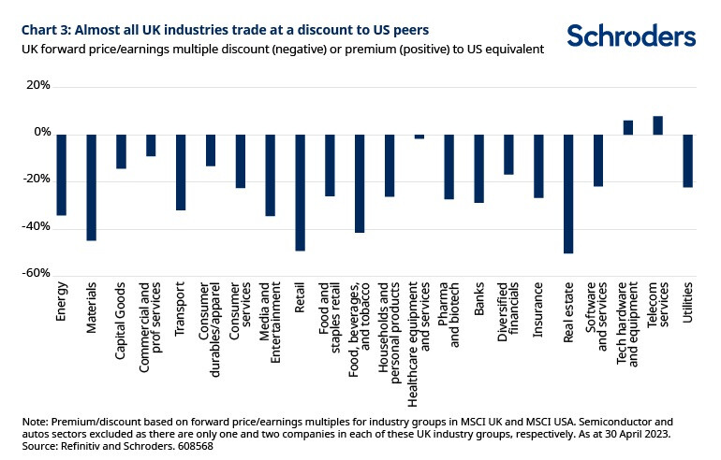
Much is often made of the US having more exposure to high growth technology companies, and this being the reason for it trading at a premium to the UK. It is true that sectors with higher expected growth rates tend to trade on higher valuation multiples than those with less grand prospects.
But, while this is part of the explanation, it is insufficient. Almost every UK industry group trades at a valuation discount to the US. The UK energy sector is valued at 6.7x the next 12-months’ earnings, whereas the US energy sector is on 10.1x. The UK pharmaceutical & biotechnology sector is on 15.6x forward earnings. The US equivalent is on 21.4x. The median industry discount is 26%.
The UK doesn’t look quite as much of a bargain compared with Europe when viewed through this lens. But even here, almost two-thirds of industry groups trade cheap. The median discount is 4%.
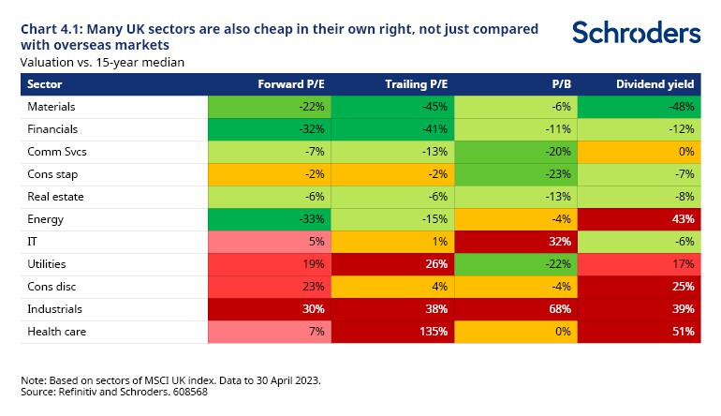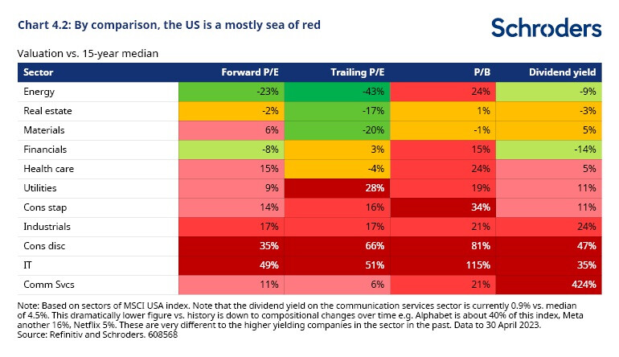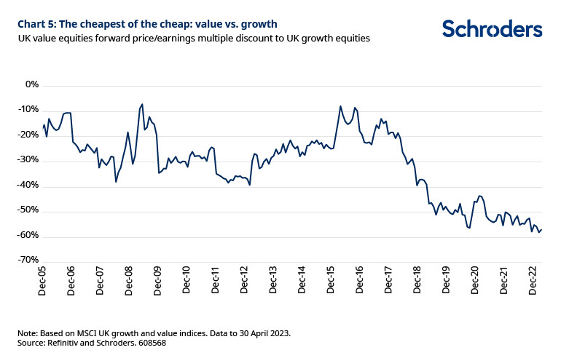
Even in a market which is cheap on many measures, value equities stand out for their cheapness. They are currently valued at a near-60% discount to their growth-peers. And, unlike other markets which saw a substantial narrowing of this discount in 2022, UK value equities have moved to even more extreme levels of cheapness.
Conclusions
Valuations of UK listed companies have taken a beating from investors in recent years. This has sunk valuations to remarkably cheap levels.
This doesn’t mean that they have to outperform or that the valuation gap has any divine right to narrow. The gap has been around for some time as international and domestic investors have shunned the market. Frustration at previous underperformance may have led some to simply stop actively considering UK equities for investment.
It could be time to revisit that stance.
Despite a generally downbeat view of the UK market, it has been quietly outperforming. Since the end of 2020, UK equities have returned 37% compared with only 21% for the US, in sterling terms. To little fanfare, it’s also ahead of the US over the last three years.
But valuations remain weighed heavily in the UK market’s favour. Long term investors should take note.
What’s a forward price/earnings multiple?
Forward P/E is common valuation measure is the forward price-to-earnings multiple or forward P/E. We divide a stock market’s value or price by the earnings per share of all the companies over the next 12 months. A low number represents better value. An obvious drawback of this measure is that it is based on forecasts and no one knows what companies will earn in future. Analysts try to estimate this but frequently get it wrong, largely overestimating and making shares seem cheaper than they really are.
This document may contain “forward-looking” information, such as forecasts or projections. Please note that any such information is not a guarantee of any future performance and there is no assurance that any forecast or projection will be realised.
The value of investments and the income from them may go down as well as up and investors may not get back the amounts originally invested.
Past Performance is not a guide to future performance and may not be repeated.

