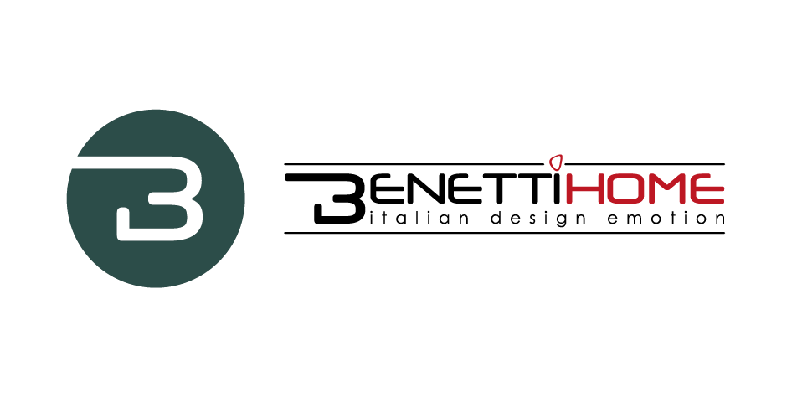
Benetti Moss in the headquarter offices of
Atalanta Bergamasca Calcio.

Benetti Home, a consolidated and dynamic Italian company offering original and personalized vertical garden walls, has recently started an important collaboration with Atalanta B.C., that consist in the placement of green moss walls in the Direction offices of the football society located in Zingonia.
The Benetti Moss product was chosen and used to realize two moss walls for the headquarter of the Serie A company with the aim of enhancing and enriching the office space.
The first panel, size 120x200cm, was realized using moss Grass and represents a football field, with the white lines that delimit the field, realized in Forex. At the center the logo of Atalanta.
The second one, size 180x240cm, was realized using the Moss Blue and the Moss City which remind the colors black and blue of the Society. In the middle of the panel “La Dea”, an unmistakable icon of this prestigious Club.
The collaboration with Atalanta B.C. shows Benetti Home qualities in the product personalization and its ability to satisfy requests of prestigious clients operating in different sectors, including the sports industry.

Benetti Home
Via Giacomo Matteotti, 34, 28060 Granozzo NO
info@benettihome.com - www.benettihome.it

OGS PR and Communication
Via Koristka 3, Milano
+39 02 3450610
www.ogscommunication.com
info@ogscommunication.com

