Warsaw, August 30, 2023

Citi Handlowy Second-Quarter Results

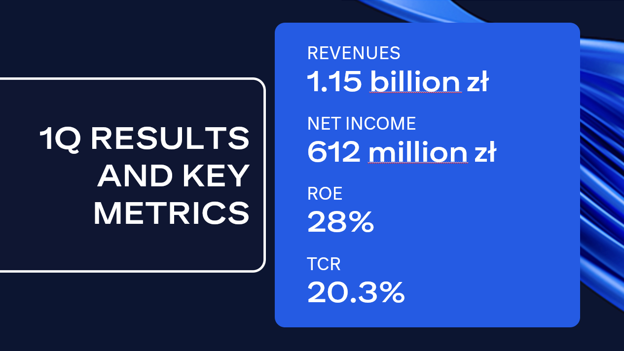

Citi Handlowy reported net income of 612 million zloty for the second quarter of 2023. This is a 22-percent increase compared to the same period last year. The results were driven by higher revenues, including strong net interest income. The bank consistently delivers its strategy of building value for shareholders, while maintaining high return on capital. At the end of June, ROE reached 28 percent and total capital ratio rose to 20.3 percent.
Total revenues increased by 14 percent y/y to 1.15 billion zloty. Net interest income amounted to 832 million zloty (+25 percent y/y). Net fees and commission income decreased by 6 percent compared to the previous year, which was affected by one-off events last year. Operating costs totaled 340 million zloty and increased by 13 percent y/y, mainly due to high inflation. The cost of risk decreased and was at 38 basis points (cumulated annual cost of risk).
- Our global expertise and experience in the financial markets were particularly important for our clients this quarter. Corporate clients were less interested in loans amid weaker investment activity and expected rate cuts. Therefore, we supported them in currency heading transactions, provided solutions for increasing capital and issuing debt - said Chief Executive Officer Elżbieta Czetwertyńska. - We’ve been modernizing our banking platforms. Many corporate customers already enjoy new features in CitiDirect online banking. This system allows them to manage their finances in different parts of the world in a simpler and more intuitive manner. In the second quarter we also saw growth in wealth management and greater interest in our credit cards.
In line with its strategy, Citi Handlowy is focusing on institutional banking. In the second quarter, the bank and Citi acted as global coordinators in the in 505-million zloty accelerated book-building for a leader in the footwear industry. Citi Handlowy was also part of a consortium of banks providing 1.57 billion zloty in financing to Emitel. The financing included a term loan, an investment loan and a revolving loan. The bank signed another financial agreement with Żabka, which entails implementation of ESG objectives.
FX volumes in commercial banking increased by 3 percent y/y. In the Institutional Banking segment, Citi Handlowy recorded a 7-percent drop in loans y/y.
In consumer banking, the number of Citigold Private Clients increased by 14 percent y/y. As a result, deposits also increased by 4 percent in the same period. In turn, assets in investment products increased by 7 percent. At the same time, the number of clients using the Citi Kantor platform broke another record, and the number of FX transactions was higher by 40 percent y/y. Customers' interest in credit cards increased - the acquisition of new credit cards increased by 70 percent y/y , and the number and value of transactions in the existing portfolio was higher compared to the same period last year.
The profitability ratio (ROE) was at the level of 28 percent, cost-to-income ratio was 30 percent. This was achieved as the bank’s capital increased, which resulted in total capital ratio of 20.3 percent (an increase of 2.6 percentage points compared to the same period last year).
- The second quarter was undoubtedly time of increased effort in terms of effective capital management. We focused on activities aimed at improving the capital position. In view of reduced interest in loans and the continuation of upward trend in deposit volumes, we actively managed liquidity and currency positions. We are pleased that our activities have brought the intended effect, significantly improving the capital ratio. They also had a positive impact on the result on treasury activities, which grew by 3 percent versus the previous quarter - said Chief Financial Officer Natalia Bożek.
In July this year, Citi said that it plans to resume the process of exiting the consumer business in Poland. According to its strategy, Citi will focus on expanding institutional business in Poland.

For additional information:

Marta Wałdoch, spokesperson, phone 605 990 433
E-mail: marta.waldoch@citi.com

Zuzanna Przepiórkiewicz, media relation specialist, phone. 667 635 432
E-mail: zuzanna.przepiorkiewicz@citi.com

Bank Handlowy w Warszawie SA is one of the largest financial institutions in Poland. Under the brand name Citi Handlowy, it offers various advanced products and services in the areas of corporate, investment and retail banking. Bank Handlowy provides services to almost 5,500 corporate clients and around 568,000 individual customers through modern distribution channels and a branch network. As a member of Citigroup, the largest financial institution worldwide, Bank Handlowy provides its clients with access to financial services in more than 100 countries.

Citi is a leading banking partner for institutions with international needs, a global leader in asset management, and a bank valued by individual customers in its domestic market in the United States. Citi operates in over 160 countries and jurisdictions, offering a wide range of financial products and services to its corporate, government, institutional and individual clients. For more information, please visit www.citigroup.com | Twitter: @Citi | YouTube: www.youtube.com/citi | Blog: http://blog.citigroup.com | Facebook: www.facebook.com/citi | LinkedIn: www.linkedin.com/company/citi

