Smaller US companies: you don’t need to pay a premium to access the US economy
Over much of the last decade investing exclusively in the S&P500 would have been the best decision. Change is now underway and there are compelling arguments – and value is just one of these – to look to smaller and mid-size companies for US exposure.

Bob Kaynor, Head of US Small & Midcap Equities da Schroders

Over the past 20 years smaller US companies have rarely been so cheap relative to large caps as they are today. They are pricing in a lot of bad news. Indeed, US smaller companies trade at similar valuations to markets outside the US for the first time in years – offering investors a route into the US economy without paying a premium.
US small cap vs large cap stocks: close to the cheapest level in 20 years
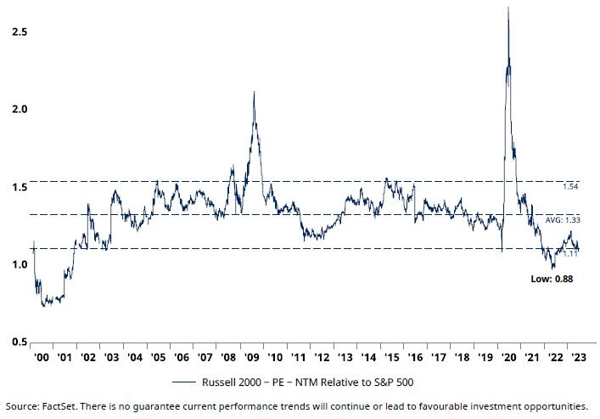
History points to a small and mid-cap rebound
The last time relative valuations were this cheap, and sentiment so poor, was followed by an outstanding period of absolute and relative returns for small and mid-cap companies.
In the seven-year period following the market peak in March 2000, small caps rose by more than 70% compared to a rise of less than 10% for large cap stocks.
This outperformance from smaller companies occurred during periods when interest rates and economic growth were both rising and falling – suggesting the outperformance can arise through a variety of economic environments.
Past performance is no guide to the future, of course, but we see many similarities with the current environment.
Previous small cap outperformance occurred in a range of economic and rate environments
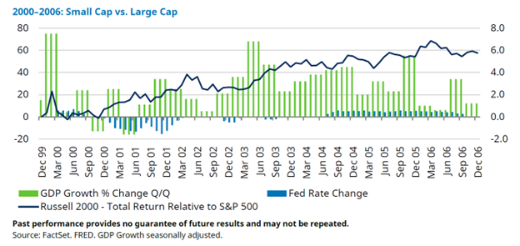
Small and midcaps offer diversified exposure at a time of concentration
The S&P 500 has become increasingly concentrated in a very few mega cap tech companies. In fact, just a handful of US stocks have become so highly priced that they dwarf the value of entire markets. For example as of end August the “Super-7” US stocks – Apple, Microsoft, Alphabet, Amazon, Nvidia, Tesla and Meta – made up more of the global index MSCI ACWI than the markets of France, China, the UK and Japan combined.*
US smaller companies offer a much more diversified exposure to the US economy, giving a different risk profile.
Large cap vs small cap US stocks: economic exposure
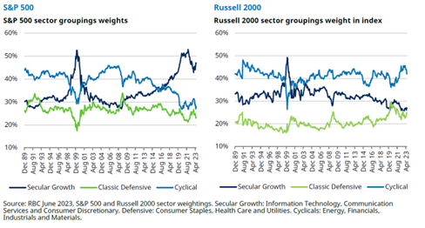
Smaller caps benefit from a switch to services and the “reshoring” trends
Smaller, more domestically-oriented companies in the US are often better positioned to benefit from changing trends in the US economy. Although the US consumer remains resilient, consumer spending is changing from goods to services.
The goods economy remained robust during the Covid-19 pandemic, while the services economy was largely closed. Smaller company earnings are much more geared to services, which should further fuel favourable relative earnings growth.
Another trend that was evident before the Covid-19 crisis, but has since accelerated, is the rise in capital spending in the US. There is a major initiative underway to reshore supply chains as globalisation starts to retreat. The US government is also providing major incentives to promote more domestic manufacturing enshrined in legislation through policy such as the Chips and Science Act, and the Inflation Reduction Act passed in 2022. The Infrastructure Bill of 2021 provides additional tailwinds.
Other factors supporting capex are efforts to reduce emissions and the need to spend on automation to mitigate labour shortages. Sales growth of smaller companies is highly correlated to US capex growth. This reflects the largely domestic focus of small cap businesses compared to large caps. This domestic exposure also insulates companies from translating non-US returns into US dollars.
Lastly… “small cap” in the US universe isn’t always small
It’s important to remember, given the size of the US economy, even “small” US-focused companies are large by international standards. This is important at a time when investors are re-discovering risk as liquidity tightens due to rising interest rates. With market valuations ranging up to $20 billion, however, US small and mid-caps are a well-traded and liquid asset class – and one which is full of opportunities.
*SOURCE: Data as at 31 August 2023. Source: Refinitiv, Schroders.

